REPUBLIC OF NAURU
NATIONAL SOLID WASTE MANAGEMENT STRATEGY
2017-2026

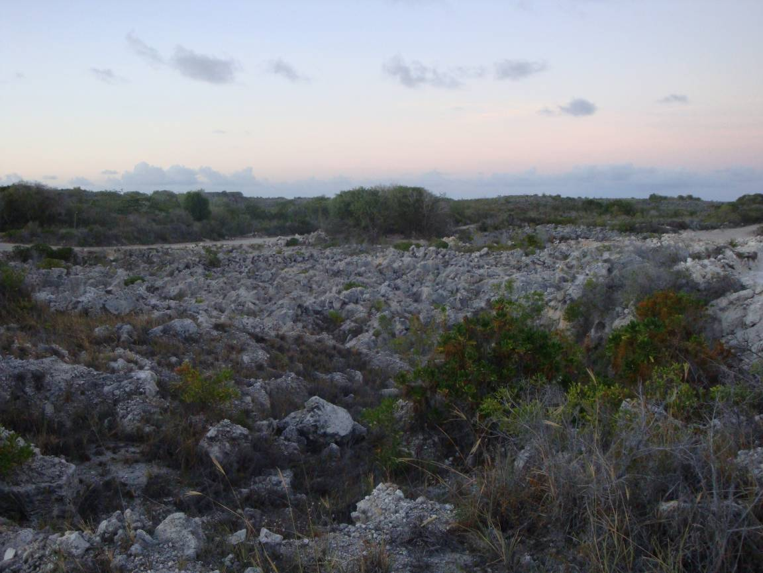

FOREWORD
The National Solid Waste Management Strategy (NSWS) has been develop and under-went to consultations with SPREP/JICA and is in lined with the National Sustainable Development Strategy (NSDS) to strengthen the solid, hazardous waste and e-waste by improving, the capacity to manage. The Strategy promotes and reinforces responsible of Solid Waste Management by including responsibility and mandatory advanced recycling fees, where necessary and to reduce environmental pollution from the generation and disposal of solid waste.

Nauru is a small island in appropriate for imports of excessive non-biodegradable packaging and a harsh environment decreasing the life of many consumer goods. The long distances between island and relatively small volumes place conventional solutions like recycling beyond the reach of most inhabitants

Waste is an economic as well as an environmental issue. Increasingly, Nauru necessity to rely on tourist image as a ‘pleasant island’ but litter on roads and beaches will slow this important economic drive waste is also inflating our healthcare costs by increasing pollution and mosquito breeding which cause disease like dengue and malaria. Not managing waste well is already costing Nauru significantly.

CONTENTS

FOREWORD iii
CONTENTS iv
ACRONYMS v
ACKNOWLEDGEMENTS Error! Bookmark not defined.
EXECUTIVE SUMMARY 1
VISION, GOALS, TARGETS 1
SCOPE AND TIMEFRAME 2
COORDINATION OF THE STRATEGY 2
MEASURING PROGRESS 2
INTRODUCTION 4
NEED FOR A STRATEGY 4
BACKGROUND 4
COUNTRY INFORMATION 4
STRATEGIC CONTEXT 5
ANALYSIS OF CURRENT SITUATION 7
A NEW APPROACH TO SOLID WASTE MANAGEMENT 14
THE WAY FORWARD 14
GUIDING PRINCIPLES 14
VISION AND GOALS 15
SCOPE 15
IMPLEMENTATION TIMEFRAME 15
THEMATIC PRIORITIES 15
A. LEGISLATION 16
B. EDUCATION AND AWARENESS 16
C. CAPACITY BUILDING 17
D. WASTE COLLECTION AND DISPOSAL 17
E. WASTE REDUCTION, REUSE, AND RECYCLING 18
F. SUSTAINABLE FINANCING 19
COORDINATION OF THE STRATEGY 19
MEASURING PROGRESS 20
APPENDIX A – Stakeholders Consulted 21

ACRONYMS

CIE Department of Commerce, Industry, and the Environment
FFA Forum Fisheries Association
kg Kilograms
KPI Key Performance Indicators
MARPOL Convention for the Prevention of Pollution from Ships\
NRC Nauru Rehabilitation Corporation
NSDS National Sustainable Development Strategy 2005-2025
PIDP Pacific Islands Development Programme
PIFACC Pacific Islands Framework for Action on Climate Change
PIFS Pacific Islands Forum Secretariat
PPA Pacific Power Association
SOPAC South Pacific Applied Geoscience Commission
SPC Secretariat of the Pacific Community
SPREP Secretariat of the Pacific Regional Environment Programme
USP University of the South Pacific

ACKNOWLEDGEMENTS
Special acknowledgement to Ms Esther Richards from Secretariat of the Regional Environment Programme (SPREP) and Japan International Cooperation Agency (JICA), Department of Commerce Industry & Environment (CIE) and the Stakeholders for their support, assistance and valuable reviews for completion of this Strategy.

EXECUTIVE SUMMARY

Nauru faces many economic and environmental challenges. In the 1970s the country experienced an economic boom due to phosphate mining, however, because of mismanagement of the revenue, the country currently has limited financial resources to undertake many of its development programmes including environmentally sound waste management. In the face of a range of environmental, social and economic threats from poor waste management and pollution, and in the context of the limited resources, this National Solid Waste Management Strategy is developed as a matter of priority.

The proposed way forward is based on an analysis of the existing situation and was developed using a participatory and consultative approach through workshops held in November 2008 and October 2010.

VISION, GOALS, TARGETS
The vision for the National Solid Waste Management Strategy is identical to the strategic goal identified in Nauru’s National Sustainable Development Strategy 2005-2025: Effective management of waste and pollution that minimizes negative impacts on public health and environment. This vision is underpinned by three goals:

- To reduce environmental pollution from the generation and disposal of solid waste
- To increase economic benefits and efficiency by reusing and recycling wastes where possible
- To reduce the costs to society of managing waste through efficient and responsible management and equitable distribution of costs

To achieve the stated goals, 6 priority thematic areas were identified through wide stakeholder consultations. These thematic areas in no order of priority, are (A) legislation; (B) awareness; (C) capacity building; (D) waste disposal; (E) waste reduction, reuse, and recycling; and (F) sustainable financing.

The specific targets for each of these 6 areas are:
- Practical and enforceable regulations for waste management enacted by 2019, and enforced beginning in 2020.
- Increase the percentage of the population aware of and engaging in good solid waste management practices by at least 10% yearly over the 2017 levels.
- Solid waste management integrated into the Nauru school curriculum by 2017.
- By 2017, adequate numbers of trained staff are effectively implementing the National Solid Waste Management Strategy, and there is a plan in place for continuous staff development.
- Improved operation and management of the NRC-managed dumpsite by 2017 in order to extend the operational life and minimize the pollution risks and other environmental impacts (odours, pests, fires, etc).
- An efficient and sustainable collection system in place by 2018.
- 30 % reduction in the amount of solid waste requiring disposal to landfill by 2020 compared to 2017 baseline data
- 75% reduction in bulky waste stockpiles by 2020.
- Fair application of the polluter pays principle – i.e., those who cause pollution should pay the cost of managing that pollution.
- At least 15% of the waste management budget generated from sustainable means by 2020, and 30% by December 2023.

SCOPE AND TIMEFRAME
The Strategy covers a 10-year period and includes solid wastes from all sources (household, commercial, industrial, agricultural, and mining), and bulky wastes such as tyres, derelict vehicles, and waste from construction and demolition. The Strategy will be updated periodically to include hazardous waste, health-care waste, liquid waste, and gaseous wastes as the institutional capacity to implement the Strategy increases.

COORDINATION OF THE STRATEGY
The Department of Commerce, Industry and Environment will coordinate the implementation of the National Solid Waste Management Strategy. A multi-stakeholder forum will also be used to provide additional support to periodically review progress and provide feedback.

MEASURING PROGRESS
The National Solid Waste Management Strategy will be reviewed during its mid-term in 2019. Measuring the overall success of the Strategy will be based on key performance indicators, as identified in the National Sustainable Development Strategy 2005-2025:
- Proportion of waste effectively and sustainably managed
- Proportion of waste avoided (e.g. through import bans)
- Proportion of waste recycled or composted
- Proportion of estimated waste generated that is disposed of at the designated disposal site

- Number of national and sector policies, plans and programs in which waste and pollution issues have been integrated.

INTRODUCTION

NEED FOR A STRATEGY
Nauru faces many economic and environmental challenges. In the 1970s the country experienced an economic boom due to phosphate mining, however, because of mismanagement of the revenue, the country has limited financial resources to undertake many of its development programmes including environmentally sound waste management.

Poor waste management can have negative impacts on public health, the environment, and the national economy. From a public health standpoint, poor waste disposal practices encourage mosquitoes, rodents, and other vermin populations, which can spread diseases. Respiratory and other health problems can also arise from breathing the fumes from dumpsite fires. From the environmental perspective, dumpsites threaten underground sources of water, and air quality, and can also reduce the ability of natural systems such as coral reefs to cope with other events such as climate change. Economically, poorly managed wastes affect tourism, fisheries, and agriculture.

On the other hand, the benefits from proper waste management include the enhancement of tourism, a more resilient and healthier environment, reduced health care cost and the maximization of infrastructure lifetimes such as landfills and collection systems. At the same time, the small population size and close-knit communities of Nauru suggest that sustainable solid waste management can be achieved.

In the face of the environmental, social and economic threats from poor waste management and pollution, and in the context of the limited resources, there is an urgent need to develop sustainable methods for managing waste. The development of this National Solid Waste Management Strategy is therefore a priority for Nauru.

BACKGROUND

COUNTRY INFORMATION
Geographic location | 0° 32’ South 166° 55’ East
Geological characteristics | Raised atoll
Capital | Yaren District
Population | 10,163 (source: SPC 2008)
Land Area | 21 square kilometres
Population density | 484 persons per square kilometres
Median age | 21.7 years
Youth (15-24) | 21.1 percent
Max height above sea level | 70 m (location along plateau ring)
Rainfall | 2,090 mm/annum (source: SOPAC, 2007)
Exclusive Economic Zone | 320,000 square kilometres
Mean Temperature | 29 degrees Celsius
GDP per Capita | US$2,500 (source: ADB)
Economic activities (main) | Phosphate mining, fisheries
Currency | Australian Dollar
Transportation links | AIR: Twice per week flights by Our Airline (Brisbane, Tarawa)  SEA: Neptune Pacific Line to Brisbane (about every 2 weeks)
Languages | Nauruan, English
Government | Republic with parliamentary system
Memberships in regional organizations | FFA, PIDP, PIFS, PPA, SPC, SPREP, SOPAC, USP
Natural hazards | Tsunamis, Droughts

STRATEGIC CONTEXT
Regional Context: | The Pacific Regional Solid Waste Management Strategy  The Pacific Regional Solid Waste Management Strategy 2010-2015 is the region’s guiding document for solid waste management, whose implementation is coordinated by SPREP. It prescribes actions for SPREP and SPREP member countries and territories including Nauru. It addresses nine priority areas: sustainable financing; integrated solid waste management; legislation; awareness, communication and education; capacity building; environmental monitoring; policy, planning and performance; solid waste industry; and medical waste.  Of these areas, Nauru identified three high priorities: (1) integrated solid waste management, (2) legislation, and (3) Policy, Planning & performance. The Nauru Waste Management Strategy should be closely aligned with the Regional Strategy by aligning relevant strategies and high-level actions.  Pacific Islands Framework for Action on Climate Change 2006-2015  The Pacific Islands Framework for Action on Climate Change (PIFACC), which was endorsed by the Pacific Islands Forum Leaders in 2005, establishes a framework to ensure that Pacific island peoples and communities build their capacity to be resilient to the risks and impacts of climate change. Two of the key expected outcomes of the PIFACC are to implement adaptation measures to the adverse effects of climate change and to contribute to global greenhouse gas reduction.  Implementation of the Nauru Waste Management Strategy should lead to better waste management which in turn can contribute to adaptation to climate change, since it can lead to reduced discharge of leachate and the lower levels of pollution from litter, poorly managed dumpsites, etc. These positive effects reduce the manmade stresses on the ecosystems such as reefs, thus allowing them to better cope with climate change impacts. In terms of mitigation of greenhouse gases such as methane, better waste disposal methods such as semi-aerobic landfills and home composting can reduce the production of methane.
National Context: | The National Sustainable Development Strategy (NSDS) 2005-2025 (revised in 2009) outlines a vision for Nauru’s development: “A future where individual, community, business and government partnerships contribute to a sustainable quality of life for all Nauruans”.  Under the Environment Sector of the NSDS, goals, key performance indicators (KPIs), and milestones are specified for waste management, which should be incorporated in this National Solid Waste Management Strategy:  Goal: Effective management of waste and pollution that minimizes negative impacts on public health and the environment.  KPIs: Proportion of waste effectively and sustainably managed;  Number of national and sector policies, plans and programs in which waste and pollution issues have been integrated.  By 2017: National solid waste management strategy finalized and implemented  By 2025: Pollution and waste management efforts become sustainable

ANALYSIS OF CURRENT SITUATION
Legislation: | Litter Prohibition Act 1983  This act makes provisions for the abatement of litter. It prescribes fines for littering offences and empowers district constables to enforce the act.  However, as cited in a review of Nauru’s environmental legislation [Powell, 2006], the Litter Prohibition Act “is often ignored by both young and old, because of either ignorance or perceived immunity from prosecution.” The review goes on further to suggest that “the method and degree of enforcement and imposition of penalties need to be broadly re-considered in view of the apparent general attitude of the Nauruan people, and some lateral thinking applied to find solutions.”  During stakeholder consultations, the views expressed by Powell [2006] were strongly disputed. Based on the stakeholder feedback, the current attitudes towards legislation have probably changed since the assessment was completed in 2006.  Marine Pollution Prevention Bill 2000  This bill was drafted to implement the provisions of the International Convention for the Prevention of Pollution from Ships (MARPOL). It makes provisions for dumping of wastes at sea.  Environment Management Bill 2006  This framework bill makes provision for issues related to the management and protection of the environment, and permits regulations to be made for environmental matters, including:  - regulating or prohibiting the pollution of the air, water or land, and the depositing or dumping of litter, rubbish, or any substance of a dangerous, noxious or offensive nature;  - managing landfill sites and otherwise providing for the administration, management and regulation of waste management processes, facilities and services;  - prescribing fees for applications, permits or approvals under any law relating to the management of the environment, or for the provision of advisory, inspection or other services by CIE.  The Environment Management Bill has been sent to regional partners for comments and there has been at least one offer of assistance to review and finalize the bill.  Analysis: The existing legislative framework for solid waste management does not adequately address the range of issues necessary for proper solid waste management (e.g. waste storage and collection, landfill operation, fees, etc). The Environment Management Bill, once enacted, provides for the development of such regulations.
Institutional arrangements: | The Department of Commerce, Industry & Environment (CIE) is responsible for the strategic planning and regulatory aspects of waste management. CIE has recently increased its capacity by employing an Environment Policy Officer and an Environment Project Officer.  Solid waste management operations (waste collection & disposal) are carried out by the Nauru Rehabilitation Corporation, as mandated by the Minister of CIE.  Analysis: The separation of the regulatory aspects from the operational aspects of solid waste management in two separate agencies is good and avoids self-regulation. The recent increase in capacity in CIE is also a positive move forward. While these two bodies have clearly defined roles, a multi-stakeholder forum could provide additional support to periodically review progress on the solid waste management strategy.
Financing: | The waste management operational budget for waste collection and disposal for the 2010 financial year (July 2010-June 2011) is about AU$170,000, while the capital expenditure (equipment) is $661,000. A small portion of the operational budget comes from charging schools, hospitals, and government buildings for waste collection services, while the remainder is absorbed into the annual budget for the Nauru Rehabilitation Corporation.  Analysis: Sustainable financing is critical to ensuring the longevity of waste management programmes. There is a need for an injection of funds to support capital projects such as dumpsite improvement. Furthermore, it is necessary to move towards a self-sustaining system where the waste management operational budget is self sustaining.
Waste generation: | The most recent waste generation study dates to 1994 [Baines, 1994] when Nauru was at the height of an economic boom. The waste generation estimate was 500 kg/person/year with the components shown in the following table.  In 2003, a household waste generation survey was conducted in Buada community. The results (shown below) differ considerably with the national average estimated in 1994.  Analysis: The available waste generation data is very outdated and is likely to be unreliable. Furthermore, there is no available waste generation statistics from the commercial and industrial sectors which may be responsible for a major portion of the waste stream. The waste generation baseline therefore needs to be established in order to validate or further inform the refinement of the National Solid Waste Management Strategy.
  Waste Component | Percent of total (%) | Estimate of Per capita generation (kg/person/yr) | Estimate of total generation for Nauru (kg/person/yr)
  Green wastes | 40 | 200 | 3000
  Food wastes | 7 | 35 | 525
  Cardboard | 10 | 50 | 750
  Paper | 8 | 40 | 600
  Plastics | 10 | 50 | 750
  Textiles | 5 | 25 | 375
  Glass | 5 | 25 | 375
  Wood | 3 | 15 | 225
  Rubber | 2 | 10 | 150
  Steel cans | 2 | 10 | 150
  Aluminium | 1 | 5 | 75
  Other metals | 5 | 25 | 375
  Misc (dirt, ash, etc) | 2 | 10 | 150
  TOTALS | 100 | 500 | 7500
Waste collection: | The Nauru Rehabilitation Corporation operates the collection system. There is one (1) garbage compactor truck, which has not functioned for over 2 years due to mechanical problems. Waste collection is therefore carried out using 2 pickup trucks which can transport 15-20 wheelie bins each. With daily waste collection, about 60-80 bins are emptied daily.  A new compactor truck is expected to be delivered before the end of 2010, and the plan is to repair the existing truck to be used as a backup.  A skip-bin waste collection service is provided for the hospital ($200/month), government buildings ($200/month), and some schools ($100/month). This paid service does not currently extend to private businesses whose waste is collected for free.  Analysis: With the addition of a new compactor truck, the efficiency of the waste collection system is expected to improve. However, a daily collection service will increase wear and tear on the vehicle, and increases operational cost. Regular preventative maintenance of the vehicle and timely sourcing of spare parts will also be essential to minimizing long down-times due to mechanical failure. Furthermore, the free collection and disposal service provided to private businesses need to be re-examined in light of the charges to schools, and the hospital.
Waste recycling: | There are two persons engaged in commercial recycling activities on a small scale. One of these persons collects, bales and exports copper radiators and aluminium cans. He purchases aluminium cans from the public at AU$0.40 per kilo, and has accumulated a full 20-foot container load of aluminium cans ready for export. Unfortunately, there are no fiscal measures to support the recycling sector.  Analysis: The private sector has shown initiative and interest in waste recycling; however the lack of fiscal measures such as container deposit legislation to support recycling efforts makes it difficult to maintain a self-financing operation. Consideration must be given to measures to support small and micro enterprises engaged in waste management, as this is also identified as a priority in the National Sustainable Development Strategy.
Solid waste disposal: | The disposal method on Nauru is an open dump method at the NRC-managed dumpsite located in the south-west of the island. The dumpsite covers a fairly large area and is a pollution threat to underground water reserves as shown in the map below.  Segregation bays were constructed sometime in the past to allow for the separation of recyclables, however, these are not functioning. The operating hours of the NRC-managed dumpsite are from 7am to 3:30pm and attempts are made to control access through a lockable access gate and posted security personnel. However, it is not uncommon to find waste pickers on the site. Dumpsite fires are also a common occurrence.  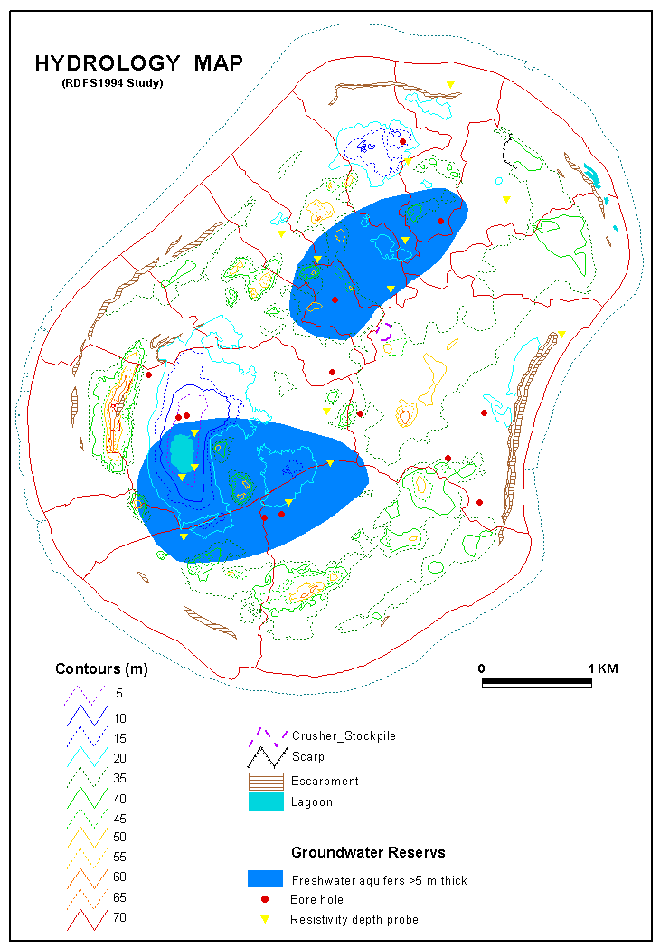  NRC-managed Dumpsite  X  Map Source: Baines, 1994  Bulky scrap metals such as cars, and disused equipment, and other wastes such as tyres, are being stockpiled along the dumpsite’s perimeter fence (see picture below), however, there is no plan in place to recycle this waste. Abandoned bulky wastes and other forms of litter can also be observed in numerous locations throughout the island.  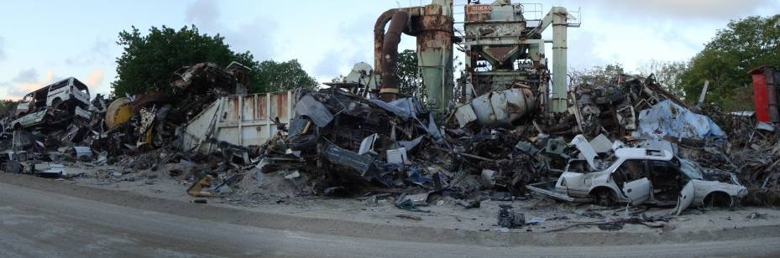  Analysis: The current dumpsite has some good basic infrastructure such as perimeter fence, and segregation bays, however the operation of the dumpsite could be improved inexpensively to be more sanitary. The segregation of bulky waste is a positive action, however further action needs to be taken to recycle this waste and also other bulky waste abandoned throughout the island.
Education and awareness: | Waste education is not a formal component of the school curriculum, but there are some awareness activities conducted with schools and very limited activities in the communities.  Analysis: Education and awareness are essential components of a good waste management programme. A sustained and integrated effort is required in order to influence the value system of people, and achieve a positive behavioural change. This must include educating the young and the old.

A NEW APPROACH TO SOLID WASTE MANAGEMENT

THE WAY FORWARD
The proposed way forward is based on the preceding analysis of the existing situation and was developed using a participatory and consultative approach. The skeleton of the National Solid Waste Management Strategy was developed after a national consultation workshop with approximately 15 stakeholders in November 2008. This was followed by a second consultation workshop in October 2010 to finalize the Strategy. A list of stakeholders consulted during these workshops can be found in Appendix I.

The way forward consists of three elements: firstly, there is a need to establish the appropriate framework and standards for proper waste management through the development of appropriate legislation and policies. Secondly, it is believed that positive changes to waste management can be brought about by focusing on the people – more specifically, by gaining support from politicians, by changing people’s behaviours through awareness, and by building up the human resource capacity within the country.

Finally, as the supporting regulatory framework and human capacity increases, it is expected that sustainable systems for collection, disposal, and recycling would function more effectively.

GUIDING PRINCIPLES
The way forward will be built on the following guiding principles:

Polluter-Pay Principle: | Those responsible for causing pollution should pay the cost of managing the pollution in order to maintain a healthy environment.
Precautionary Principle: | Lack of scientific data/information certainty should not be used as a reason for not acting to prevent serious or irreversible environmental damage or degradation.
Proximity Principle: | Waste should be dealt with as close as possible to the source of generation. This will reduce transportation costs, and contamination risks
Consultation Principle: | Government at all levels will consult and work with people and organizations throughout the development and implementation of the waste management strategies and action plan

VISION AND GOALS
The Vision for this National Solid Waste Management Strategy is based on the goals identified in Nauru’s National Sustainable Development Strategy 2005-2025:

Effective management of waste and pollution that minimizes negative impacts on public health and environment

This vision is underpinned by three goals which are grounded in the analysis of the current waste management situation and which also reflect the Government’s commitment to achieving sustainable development:

- To reduce environmental pollution from the generation and disposal of solid waste
- To increase economic benefits and efficiency by reusing and recycling wastes where possible
- To reduce the costs to society of managing waste through efficient and responsible management and equitable distribution of costs

SCOPE
The Strategy covers solid wastes from all sources (household, commercial, industrial, agricultural, and mining). It also covers bulky wastes such as tyres, derelict vehicles, and waste from construction and demolition. The Strategy does not cover hazardous waste, health-care waste, liquid waste, or gaseous wastes. It is envisioned that these will be included in subsequent revisions of the Strategy and as the institutional capacity to implement the Strategy increases.

IMPLEMENTATION TIMEFRAME
This Strategy covers a 10-year implementation period from 2017-2026. It is recommended that a mid-term review and evaluation of the Strategy be conduced in 2019 to ensure that it is adapted to address changing needs and new or emerging priorities.

THEMATIC PRIORITIES
To achieve the stated goals, 6 priority thematic areas were identified through wide stakeholder consultations. These thematic areas in no order of priority, are (A) legislation; (B) awareness; (C) capacity building; (D) waste disposal; (E) waste reduction, reuse, and recycling; and (F) sustainable financing.

Each of these thematic areas is expanded by looking briefly at the key issues, setting targets, and outlining the strategies for achieving those targets. The strategies are numbered continuously from one thematic area to the next.

A. LEGISLATION

The issues
An environmental management bill has already been drafted and is currently being reviewed. This bill provides for the development of regulations pertaining to waste management; however such regulations have not yet been drafted.

The Litter Prohibition Act addresses littering, however this also needs to be reviewed and consolidated to increase effectiveness and address the changing nature of today’s waste.

What we want to achieve
- Practical and enforceable regulations for waste management enacted by 2019, and enforced beginning in 2020.

How we will achieve the targets
- Develop appropriate solid waste management regulations.

B. EDUCATION AND AWARENESS

The issues
There is a lack of awareness of the negative impacts of poor solid waste management as demonstrated by the illegal dumping of rubbish and widespread littering. To some extent, there is also a lack of public interest in the issue of solid waste management. It is therefore critical to increase the level of awareness of the public through consumer education in order to gain support for solid waste management programmes. The public needs to understand the negative effects associated with a dirty environment.

What we want to achieve
- Increase the percentage of the population aware of and engaging in good solid waste management practices by at least 10% yearly over the 2017 levels.
- Solid waste management integrated into the Nauru school curriculum by 2018.

How we will achieve the targets
- Develop an appropriate waste management learning programme for primary and secondary schools.
- Develop a program for solid waste management awareness in Nauru.

C. CAPACITY BUILDING

The issues
The Department of Commerce, Industry and Environment has recently appointed an Environment Policy Officer, and an Environment Project Officer, thus increasing the number of staff (non-project) in the environment department from 3 to 5.

The Nauru Rehabilitation Corporation responsible for waste collection and disposal also has staff to implement those services.

The number of available staff to deal with waste management in improving, however there is a need to expand the technical capacity and knowledge base of these staff members, especially the recent ones.

What we want to achieve
- By 2017, adequate numbers of trained staff are effectively implementing the National Solid Waste Management Strategy, and there is a plan in place for continuous staff development.

How we will achieve the targets
- Identify and access relevant and practical training opportunities for staff members in order to increase the number of people trained to the certificate level or higher in solid waste management.
- Require minimum competency levels for working in waste management.

D. WASTE COLLECTION AND DISPOSAL

The Issues
The NRC-managed dumpsite is an open dump which:
- is accessible to the public for scavenging and is therefore a health risk
- is a pollution risk to underground water reserves
- is a source of air pollution from uncontrolled fires.

There are simple techniques based on the semi-aerobic landfill technique, which have been successfully used in other small islands to improve dumpsite operation and these can be applied to NRC-managed dumpsite to incrementally improve the operation of the dump.
Waste is collected daily from all areas, and it is reported that the bins are usually full. The waste collection system is expected to further improve by the end of 2020 with the purchase of a compactor truck, however, the costs versus the benefits of providing a daily waste collection frequency is worth examining, especially considering the size of the island, and the challenges with equipment maintenance.

What we want to achieve
- Improved operation and management of the NRC-managed dumpsite by 2017 in order to extend the operational life and minimize the pollution risks and other environmental impacts (odours, pests, fires, etc).
- An efficient and sustainable collection system in place by 2018.

How we will achieve the targets
- Incrementally improve the technical operation and management of the NRC-managed dumpsite based on the semi-aerobic (Fukuoka) landfill.
- Improve the efficiency and cost-effectiveness of the current waste collection and disposal systems.

E. WASTE REDUCTION, REUSE, AND RECYCLING

The Issues
There are no formal initiatives for waste reduction, reuse, or recycling in Nauru, despite the fact that a large portion of the waste stream could be avoided through import controls, or recycled with the aid of deposit-refund systems.

Bulky waste which can be recycled is currently segregated at the NRC-managed dumpsite; however there is no further plan in place to recycle this waste or similar waste located in communities across the island.

What we want to achieve
- 30 % reduction in the amount of solid waste requiring disposal to landfill by 2020 compared to 2017 baseline data
- 75% reduction in bulky waste stockpiles by 2020.

How we will achieve the targets
- Implement appropriate frameworks that discourage excessive waste generation, and also encourage and support recycling, focusing on:
    - container deposit legislation for aluminium and steel cans, glass, and PET bottles
    - organic waste composting
    - plastic bag control measures
- The government will take the lead and demonstrate its commitment to good waste management by adopting internal policies and practices on solid waste reduction in the workplace, and by supporting any future waste recycling initiatives through segregation of its waste.
- Consider options for stimulating and supporting private sector initiatives for waste reduction, reuse and recycling.
- Implement a bulky waste recycling project.

F. SUSTAINABLE FINANCING

The Issues
The polluter pays principle is not evenly applied. For example, schools, hospitals and government departments pay for waste collection; however, residents, businesses and industry do not pay.

There is limited finance for waste management which affects operations and maintenance of equipment, awareness programmes, and human resources development. This problem is not unique to the waste management sector, but is faced by many other sectors because of the poor economic condition of Nauru.

At the same time, Nauru is loosing an opportunity maximize economic benefits by reusing and recycling wastes such as aluminium and scrap metals. Furthermore, failure to properly manage waste and consider options such as composting of organic waste could have wider economic impacts on tourism, agriculture, and health.

If the full costs of poor waste management in Nauru were assessed, it is likely that it would exceed the cost of managing the waste properly in the first place.

What we want to achieve
- Fair application of the polluter pays principle – i.e., those who cause pollution should pay the cost of managing that pollution.
- At least 15% of the waste management budget generated from sustainable means by 2019, and 30% by December 2023.

How we will achieve the targets
- Gradually implement self-financing systems for waste recycling (e.g. container deposit legislation), collection (e.g. household user fees), and disposal (e.g. tipping fees) (refer to item #8 above).

COORDINATION OF THE STRATEGY
The Department of Commerce, Industry, and Environment will coordinate the implementation of the National Solid Waste Management Strategy. A multi-stakeholder forum will be used to provide additional support to periodically review progress on the solid waste management strategy. A forum is suggested instead of a formal committee to avoid the many problems associated with establishing and running committee meetings.

MEASURING PROGRESS
Measuring the implementation progress of this National Solid Waste Management Strategy at regular intervals is important in order to ensure that any emerging issues or barriers can be identified and addressed. It is recommended that the Strategy be reviewed during its mid-term in 2019.

Measuring the overall success of the Strategy will also be based on key performance indicators, which have been listed in the National Sustainable Development Strategy 2005-2025. These indicators are listed below and have been broken down into more detail:
- Proportion of waste effectively and sustainably managed
- Proportion of waste avoided (e.g. through import bans)
- Proportion of waste recycled or composted
- Proportion of estimated waste generated that is disposed of at the designated disposal site
- Number of national and sector policies, plans and programs in which waste and pollution issues have been integrated.

This National Solid Waste Management Strategy is implemented through an Action Plan, which outlines the specific actions, resources and timeframe necessary to achieve the targets spelt out in this strategy. It is expected that the Action Plan will be reviewed and updated as needed.

APPENDIX A – Stakeholders Consulted

 | Name | Organization | Email | Nov 2008 | Oct 2010
1 | Abraham Aremwa | CIE, Environment Project Officer | abe.aremwa@rocketmail.com |  | X
2 | Anita Koroa | Private Paper Recycler | anitakoroa@ymail.com | X
3 | Berilyn Jeremiah | CIE | berilyn.jeremiah@naurugov.nr | X
4 | Bernard Akubon | Yaren Community |  | X
5 | Bernard Grundler | Chief Secretary Dept | bernard.grundle@naurugov.nr |  | X
6 | Bryan Star | CIE (Director of Projects) | bryan.star@naurugov.nr | X | X
7 | Calistus Cain | Education Dept | calistus.cain@naurugov.nr |  | X
8 | Claudette Wharton | CIE, SLM Project | Claudette.wharton@naurugov.nr |  | X
9 | Creedence Halstead | Nauru Rehab Coorporation (Engineer) | engnauru@gmail.com | X
10 | David Dowiyogo | Baitsi Community | ddowiyogo@yahoo.com |  | X
11 | David Uera | NFMRA |  |  | X
12 | Demsey Detanamo | NRC & Aiwo Community | detenamoey@gmail.com |  | X
13 | Douglas Audoa | CIE, SLM Project | douglas.audoa@naurugov.nr |  | X
14 | Eliana Agigo | Boe Community |  | X
15 | Elna Delabene | Aiwo Community |  |  | X
16 | Godwin Cecil | CIE, SNC Project | godwin.cecil@naurugov.nr | X | X
17 | Hansome Adumure | Denig Community | hadumur@yahoo.com | X
18 | Jason Jose | Menen Community | jsnjose@hotmail.com |  | X
19 | Kristina Amram Wil-Leslie | Ronphos |  | X
20 | Lucy Duburiya | CIE (Secretary) |  | X
21 | Malaea Temeitsi | CIE (SNC Project Assistant) | malaea.termitsi@naurugov.nv | X
22 | Mark Hiram | Nauru Utilities | markhiram@hotmail.com | X
23 | Marlison Demaunga | Buada Community | tix_dem@yahoo.com | X
24 | Morley Thoma | Nauru Corporation |  | X
25 | Natasha Detenamo | CIE, PACC Project | natasha.detenamo@naurugov.nr |  | X
26 | Nerida-Ann Hubert | Anabar Community & NNYC | ann.hubert@nauru.gov.nr |  | X
27 | Nodel Neneiya | CIE, SNC Project | nodel.neneiya@naurugov.nr |  | X
28 | Pauline Eongen | Anetan Community |  | X
29 | Peta Gadabu | National Women’s Council |  | X
30 | Rene Namaduk | Ewa Community |  |  | X
31 | Richie Halstead | Tourism Department | richie.halstead@naurugov.nr | X
32 | Rosco Cain | Aid Management Unit/DPPD | rosco.cain@naurugov.nr |  | X
33 | Roxen Agadio | CIE (Environment Officer) |  | X
34 | Ruth Scotty | CIE |  | X
35 | Taralyn Hiram | NRC | hiram.trevalyn@gmail.com |  | X
36 | Thomas Star | Nauru Utilities Association | thomas.star@naurugov.nr |  | X
37 | Veronica Halstead | CIE, SLM Project | veronica.halstead@naurugov.nr |  | X
38 | Vincent Scotty | Health Department | vincent.scotty@nauru.gov.nr | X | X
39 | Zarra Adumur | Denigomodu & Denig Community | hadumur@yahoo.com | X | X
40 | Zinnah Melekiola | Ronphos |  | X

SPC (2008) 2008 Pocket Statistical Summary, Retrieved 1 August 2009, from <http://www.spc.int/prism/publications/SPS-2008.pdf >
SOPAC, (2007). Wate,r Sanitation, and Hygiene – Nauru Country Information. Retrieved 20 October 2010 from <http://www.pacificwater.org/pages.cfm/country-information/nauru.html>
Asian Development Bank, (2007). Country Economic Report – Nauru. Asian Development Bank
Powell, G.B. (2006) Review of Environment Related Laws-Nauru. SPREP, Apia, Samoa.
Baines, G. (1994). Nauru Australia Cooperation, Rehabilitation and Development Feasibility Study Environmental Cooperation Report Part B – Waste Management. Australian International Development Assistance Bureau

