Southern Islands of Pohnpei survey

1.0 Introduction
The purpose of the assessment or survey is to find current number of usable tanks available on the islands of Nukuoro and Kapingamarangi. At the same time, a sanitation survey also carried out to learn the sanitation status of the southern islands. This is the first assessment of water and sanitation of the two islands and results can be very useful data for water quality projects or other projects of water and sanitation that may rise in the future.

1.1 Geographical Location
The southern atoll islands of Pohnpei: Kapingamarangi located at latitude 1° 04' 00" North and longitude 154° 46' 00" E, and Nukuoro island located at latitude 3.8454° N and longitude 154.9415° E.

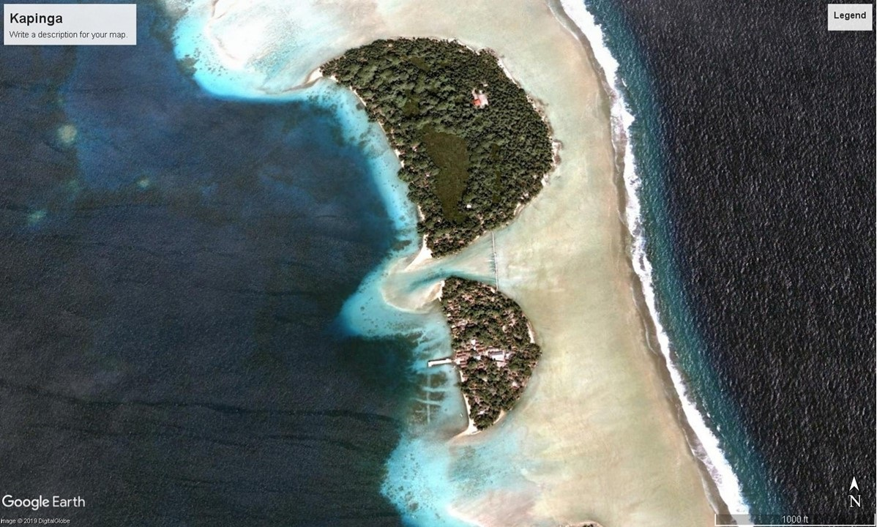 | 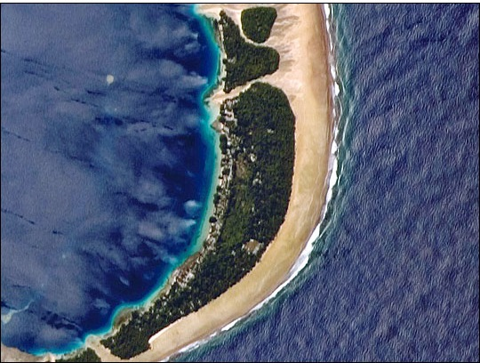
Kapingamarangi Island | Nukuoro Island

1.2 Survey Findings of the two islands
The water surveys of Kapingamarangi shows that 115 tanks are on the island and 60 tanks are in good condition with gutters installed and 55 tanks are polluted with no gutters installed. The survey also show the estimated size of the tanks are varied. They have 500-gallon tanks, 1000-gallon tank and 5000-gallon tanks. Their main source of drinking and cooking water comes from the tanks; wells are only use for bathing and laundry. As for disinfecting, only some of the household boil or disinfect their drinking water before consumption.
On Nukuoro Island, 53 tanks are in good condition with gutters installed and working properly. There were only 19 tanks that are leaking, damaged and polluted with no gutter installed. Wells were also surveyed and 18 wells working and are in use. The estimated size of the tanks on Nukuoro island range from 250 gallon to 2500 gallon. Their main source of drinking and cooking water comes from tanks. They only use wells for bathing and laundry but during droughts, they utilize the wells also for drinking and cooking. For disinfection, some of the households boil their waters before consumption.

1.3 Sanitation and Solid waste management
Based on the sanitation survey, it shows that 75% of the 2 islands use flush/pour-flush toilet facilities and 25% use overwater latrine. Majority of the households on Kapingamarangi share their toilet facilities with neighbours and visitors but as for Nukuoro Island only a few share their toilet facilities with neighbours and visitors. On the island of Kapingamarangi, all of the 115 households used flush/pour toilet facility and Nukuoro Island, 38 households were on the island and all use overwater latrines.
Type of toilet facilities use on the Islands
Kapingamarangi Island | Nukuoro Island
Flush/pour toilet facility (115 households) | Overwater latrine (38 households)
Solid waste management, Kapingamarangi Island bury most of their solid waste on a separate island and some of the households burn their solid waste. As for Nukuoro, majority of the households dispose of their solid waste on a separate island and only a few use their solid waste as a landfill material.

1.4 Definition
- Disinfection- the process of cleaning something, especially with a chemical, in order to destroy bacteria.
- Sanitation- conditions relating to public health, especially the provision of clean drinking water and adequate sewage disposal.
- Survey- look closely at or examine (someone or something)

1.5 Recommendations
- A comprehensive survey of the island is highly needed to help verify the finding of this initial survey
- It is highly recommended that a water quality analysis be carryout on Nukuoro and Kapingamarangi.
- Maintenance of the tanks are highly needed and to ensure that a routine clean up of the water tanks carried out.
- Nukuoro island need to find alternative toilet system and remove all overwater latrines.

1.6 Acknowledgement
The office of Pohnpei Environmental Protection Agency would like to thank community leaders of Kapingamarangi and Nukuoro for assisting the survey team. We hope that we can continue to work together in strengthening our duties and responsibilities in the future for the betterment of our island nation.

INFORMATION
For questions and concerns, please do contact the office of Environmental Protection Agency at 320-1780/1210.

Kalahngan,

