Yap Invasive Species Taskforce
Strategic Action Plan 2008 - 2011

First Workshop
Colonia, Yap. 21 – 22 February 2008

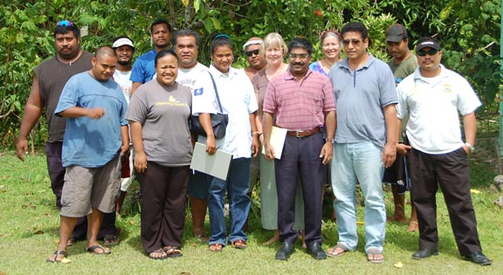
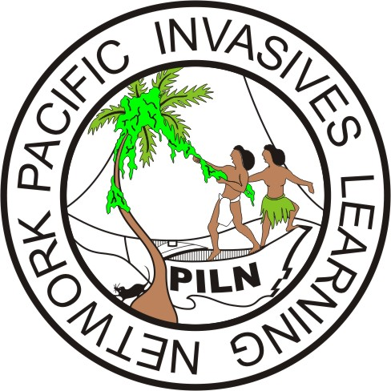
Facilitated by Jill Key, Pacific Invasives Learning Network (PILN).

Table of contents

1.0 Executive summary 3
2.0 Introduction to Invasive Species 3
3.0 Background 3
3.1 Workshop objectives 4
3.2 Expected outcomes 4
3.3 National planning framework 5
3.4 Participants 5
4.0 Vision 6
5.0 Invasive species and issues 6
6.0 YBSAP review and update 7
7.0 Strategic objectives for the 5-year plan 8
7.1 Yap invasive species taskforce 9
7.2 The planning process 9
8.0 Next Steps 10
Annex 1. Workshop agenda 12

Acknowledgements

The Yap Invasive Species Taskforce (YIST) would like to thank all the people who have been involved in this first stage of drafting the invasive species 5-year plan. Particularly we would like to thank the Department of Agriculture and Forestry for office space, and for providing refreshments.

Plans are only as good as they are used. We sincerely hope that the activities and objectives listed in this plan will be successfully executed. It is a big challenge but if we all work together and are determined our goals can be achieved.

1.0 Executive summary

The framework of the Yap invasive species 5-year plan was identified, with 3 thematic areas of concern for invasive species management in Yap State between 2008 - 2011: management action, problem definition and decision making, and generating support.

The Yap invasive species taskforce members were identified, and the planning process for completion and endorsement of the action plan mapped out. The workshop reported here is the first step in the planning process which will be completed in late June / early July 2008.

2.0 Introduction to Invasive Species

Invasive alien species have caused major biodiversity losses and ecosystem disturbance on islands worldwide. Islands are very vulnerable to biological invasions. Invasive species have directly or indirectly caused or contributed to the decline and extinction of many birds, reptiles, mammals and plants. Exotic invasive ants disrupt traditional outdoor lifestyles and cause harm to people and their crops. Invasive weeds compete with other plants for space, nutrients; and some overgrow and kill useful plants. Snakes like the brown tree snake in Guam cause significant economic losses due to power outages and biodiversity losses as a result of the extinction of several native bird species. In addition, feral pigs cause serious damage to people’s gardens resulting in crop loss.

Islands present unique opportunities to manage Invasive species. Three main ways of managing invasive species are prevention, eradication, or control. Preventing invasions of terrestrial species should be more achievable on islands than at land-locked sites. Eradication should be considered if an invasive species is newly introduced and not wide spread.

Many invasive species in neighboring countries are not present in the FSM, and within FSM many are not present in Yap. Therefore a high priority must be given to prevention of the introduction of such invasive species.

3.0 Background

The FSM National Biodiversity Strategic Action Plan was endorsed in 2002, and subsequently the Yap Biodiversity Strategic Action Plan (YBSAP) was drafted and endorsed in 2004. Strategic direction 4.4 of the YBSAP concerns invasive species: Biosecurity – addressing invasive species and other threats to biodiversity.

In November 2006 the Pohnpei invasive species strategic action plan was endorsed by Pohnpei State government, having been drafted during 2 workshops by the Pohnpei invasive species taskteam (PIST) within the framework of the Pohnpei BSAP. The simple, realistic multi-agency action plans produced for priority invasive species were seen as a model for other states, and followed in 2007 by similar action plans for Kosrae state, together with the formation of the Kosrae invasive species taskforce (KIST).

The YBSAP identifies the need to develop a 5-year invasive species plan, and this workshop was the first step in the longer process to draft the plan.

3.1 Workshop objectives
Workshop objectives were as follows:
- Revisit the actions identified in the YBSAP in 2004, and revise them as necessary;
- Develop a vision – where we want to be in 5 years time;
- Develop the long-term objectives;
- Define the national coordination mechanism and how it will function.
- Identify the immediate next steps in the planning process;

A second, more comprehensive workshop will be carried out later in 2008 to draft the action plans themselves. This allows time for consideration and reflection on the vision and objectives identified here, and also for further information to be gathered as input to the technical action plans. This process conforms to the traditional “wisdom in the basket“ approach noted in the YBSAP.

3.2 Expected outcomes
At the end of the workshop agencies and individuals in Yap state working on invasive species will have a clear long-term vision of where they want to be in 5 years time, have developed the short-term roadmap (in the form of simple, realistic action plans) of how to get there. In addition, the internal coordination mechanism will have been identified. The workshop agenda is given in Annex 1.

3.3 National planning framework

The YIST invasive species action plan forms a focal plan under the YBSAP, within the State planning framework as indicated in the following diagram.
YAP State ACTION Plan

Yap Biodiversity Strategic Action Plan

Yap Invasive Species Taskforce Strategic Action Plan

The Yap invasive species taskforce (YIST) is the coordination mechanism for the State plans with regards invasive species issues.

3.4 Participants

Name | Agency | email
Francis Liyeg | DAF
Cyril Chieng | DAF
Charlie Gilgaayan | DAF | cgilgaayan@yahoo.com
A. Wag | DHS / EH
Mary Tided | DHS/ EH | mtided@fsmhealth.fm
Henry Liyerang | DAF
Tamdad Sulog | DAF | agricultureyap@mail.fm
Tina Fillmed | EPA | tina@mail.fm / epayap@mail.fm
Margie Falanruw | USFS | mfalanruw@mail.fm
James Yinuce | MRMD | mrmdyap@amil.fm
Murukesan V. Krishnapillai | COM-FSM | muru@comfsm.fm
Stan J. Falimngar | Yap Campus, CRE | stanfal@comfsm.fm
Alexander P. Chingyan | FSM Quarantine Officer II
Andy Tafileichig | Division of Marine Resources | mrmdyap@mail.fm

4.0 Vision

Yap SAP visualizes appropriate institutional arrangements and networks in place to provide context and support for effective invasive species management, sustaining Yap islands focused effort protect crops and natural resources, on land and in the water, in order to uphold a serene environment relatively free of invasive species that supports healthy island life. At least 2 invasive species will have been eradicated by 2011.

5.0 Invasive species and issues

A brainstorming session was held to identify the main invasive species of current concern to participants:
- Rats (Rattus norvegicus) – in Yap
- Rat (Rattus exulans) – on outer uninhabited islands
- Cats
- Dogs
- Monitor lizard – outer islands
- Tilapia
- Fruit flies
- Weeds:
  - The 4 being eradicated (African tulip, Chain-of-love, Imperator and Mikania)
  - Merremia
  - Operculina
  - Mimosa invisa
  - Others

Participants noted that cane toads appear to be declining, and that this may change when rats are controlled successfully, as rats appear to prey on toads. The impact of cats will also become worse when rats are controlled in Yap. The identification of the rats in Yap was confirmed by setting 3 snap-traps in the piggery at the DAF offices. Three female Rattus norvegicus were caught over 2 nights.

Invasive species issues were then similarly brainstormed and 3 main themes were identified:

- Public awareness
- Education
- Some land and water owners

- Funding – of local actions
- Manpower
- Political support
Invasive species

- Information (but specific)

6.0 YBSAP review and update

The actions identified in the YBSAP Strategic direction 4.4 Biosecurity – addressing invasive species and other threats to biodiversity were then reviewed and updated.

Action | Update
Establish the invasive species subcommittee and develop a 5-year plan | Plan needed as resources go down. Re-activate the invasive species taskforce.
Eradicate 2 priority invasive species and monitor the results with GPS | Still valid, 4 are being tackled
Develop a rat control program | Still valid.
Develop a cat and dog neutering program | Still valid.
Pest and disease survey | Pest survey undertaken in 2004. Marine invasive species require action, specifically knowing what to look out for.
Research the ecological effects of typhoon Sudal on invasive vines | Invasive vines in general are an issue, so still valid.
Certification of pesticide applicators | Achieved, to be periodically updated.
Public awareness program on invasive species | Still valid, and high priority.
Organise an invasive species “swat team” to respond to emergencies | Still valid, but depends on government support.
Network | Achieved, through the Pacific Invasives Learning Network (PILN), the Micronesians in Conservation (MIC) network. Internal networking to be done via the invasive species taskforce.

Participants added the following actions:
- Endorsement of the taskforce
- Biosecurity strengthening – specifically snake barriers at the ports
- Monitoring – periodic, at least informally

7.0 Strategic objectives for the 5-year plan

Integrating the YBSAP actions with those now raised, the following actions are proposed, under three headings:

- Management Action (“Getting on with the job”)
  - Eradicate at least 2 priority species
- African Tulip, Chain of love, Imperator and Mikania
- Rats on uninhabited islands
  - Control other priority target species
- Rats on Yap
- Cats and dogs
- Tilapia
- Weeds
  - Certification of pesticide applicators, update
  - Strengthen biosecurity
- Snake barriers at the ports
  - Monitoring

- Problem definition and decision making (“What is the problem, and how do we deal with it?”)
  - Adapt a system for assessing risk
  - Prioritize existing invasive species for management action
  - Information gaps:
- Survey for marine invasive species
- Confirm the status of shrews on Yap
- Help in the identification of invasive grasses
- Monitor lizards on outer islands
- Generating support (“Help us”)
  - Public awareness program
  - Funding
  - Networking
  - Endorse the invasive species taskforce

7.1 Yap invasive species taskforce
The Yap invasive species taskforce will absorb the roles of the avian flu taskforce and the rat control taskforce, recognizing that these issues are all invasive species ones. Members were defined as follows:
- Agriculture and Forestry – to lead
- EPA
- Environmental Health
- Education
- Public Safety
- Quarantine
- Media
- Land Grant Program
- Health
- Marine Resources
- Yap Cap

The Yap Framers Organization will be accessed through Agriculture, as Tamdad is a member.

7.2 The planning process
The second workshop, to define the actions of the plan, will be held before the August RISC meeting, at the end of June/Early July. Participants will include all members of the taskforce, community representatives, and the following external people:
- Bill Raynor, TNC. Facilitator
- Alan Tye, SPREP Invasive Species Officer
- Joel Miles, OERC Palau.
- Phil Andreozzi, RISC Coordinator.
- Konrad Englberger, SPC Micronesia.

The completed plan will be presented to RISC for endorsement in the first instance, and to Yap State Government in the second.

8.0 Next Steps

Participants agreed to undertake the following commitments before June / July 2008:

Activity | Commitments | Who
Eradicate 2 priority species | Continue work programme | Francis
Control other priority species | Get information on various species | EPA, Sanitation, Quarantine, Ag & Forestry
Pesticide certification | Update | Ag & forestry, EPA
Monitoring | Field monitoring for weeds status | Ag & Forestry, USFS
Public awareness | Endorse existing actions | Ag & Forestry, Sanitation, EPA
Tilapia | Survey for sites  Yap day – display species and mark map for sitings  Follow-up with media  General marine survey  Proposal for survey | Marine, R&D
Monitor lizard | Check status on Ulithi and Sarol islands | MRMD, Ag & Forestry, YINS
Shrew | Confirm status | All
Urban rats | Reactivate the urban rat trap scheme  Provide more traps | Sanitation
RISC | Announce the YIST planning process  Seek assistance to strengthen biosecurity | Tamdad & Francis
Information from regional and global networks | Look for information, projects and contacts for identified species and provide it to taskforce | Jill
Next planning workshop | Share this workshop report with taskforce  Share this workshop report with external participants | Tamdad  Jill

“Act humbly – achieve greatly. Be proactive.”

Annex 1. Workshop agenda

Time | Day 1 – Developing the YIST SAP | Facilitator/lead
9:00 am | - Opening Remarks and Introductions  - Welcome remarks  - Introduction of participants  - Overview of Workshop | Tamdad  Jill
10:15 am | - Invasive species overview  - What’s the problem?  - Why make a plan? | Jill
 | 3. The national context – the NBSAP and YBSAP | Jill
10:15 am | Tea Break
10:30am | 4. Current priorities  - What are the current priority invasive species?  - What are the main issues?  - Review of the YBSAP actions | Participants
11:15 am | 5. Defining the Vision  Vision- most desirable situation for the program in some future time | Participants
11:30 pm | Adjourn

Time | Day 2 – SAP Work plan Development | Facilitator/lead
9:15am | 1. Presentation and discussion of the Vision | Jill
9:30am | 2. The taskforce | Participants
10:45am | Tea break
:00 pm | 3. Next Steps  - Agreeing on next steps, responsibilities and deadlines | Participants
11:30pm | 4. Discussion of planning process | Participants
11:40pm | 5. Closing remarks | Tamdad

Wisdom in the Basket: “Before undertaking a major action, it is wize to pause, have a chew and think it over. This is what the “Precautionary approach” is all about. “

