Yap Invasive Species Taskforce (YIST)

Strategic Action Plan

2018-2023

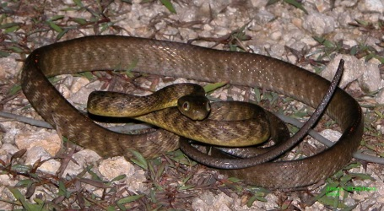

‘Working together now and in the future to protect our communities, culture and natural resources for our families and islands’

6 November 2018

Publication Data
This document was developed by the YIST during a one-day workshop in October 2018 and subsequent consultations over the following week. The document was compiled with the support of the Reginal Invasive Species Coordination Office of the Micronesia Islands Forum Secretariat.

Suggested Citation
Yap Invasive Species Taskforce. 2018. Yap Invasive Species Taskforce Strategic Action Plan 2018-2023. Pp. 23.

Cover image: Brown Treesnake, Guam by James Stanford

Table of Contents

ACKNOWLEDGEMENTS 3
ABBREVIATIONS 4
1.0 Executive Summary 5
2.0 Introduction to Invasive Species 5
3.0 Background 6
3.1 National Planning Framework 7
3.2 Other Linked Invasive Species Initiatives 7
4.0 Vision 8
5.0 Mission 8
6.0 Pest of concern 9
6.1 Priority Established Invasive Species 9
6.2 Priority High Risk Invasive Species, Which Threaten The State With Invasion 9
6.3 Priority Potenial Native Organisms With Pest Tendancies 9
6.4 Recently Eradicated Invasive Species, Which Require Follow-up To Ensure Success 10
7.0 high priority actions 10
8.0 strategic goals and objectives 11
Table 1: YIST Strategic Goals and Objectives 11
9.0 performance based invasive species work plan 16
Table 2: YIST Prevention, Management and Eradication Programs 16
10.0 Conclusion 22

Acknowledgements

YIST would like to thank everyone who participated in the drafting of the YIST Strategic Action Plan (SAP) in October 2018. Particularly, we thank the Division of Agriculture and Forestry for sponsoring and hosting the workshop and James Stanford, the Regional Invasive Species Coordinator, for assist YIST with these efforts.

The following individuals met at the Yap Agricultural facilities on 31 October 2018 to develop this updated YIST SAP for 2018 through 2023:

- Jacob Falan, Yap Environmental Protection Agency (EPA)
- Christine Fillmed, Yap EPA: epayap@mail.fm
- Ernie Guswel, Division of Agriculture and Forestry (DAF)
- Jesse Haglelfeg, Department of Health Services (DHS)
- Debra Laan, GEF-5 Ridge to Reef State Manager: debra.laan@gmail.com
- Francis Liyeg, Yap State Invasive Species Coordinator: yapinvasive@gmail.com
- Francis Ruegonong, state forester, DAF: ydafwidllife@gmail.com
- James Stanford, Regional Invasive Species Coordinator: jsecology@gmail.com
- Tamdad Sulog, Chief of Agriculture, DAF: agricultureyap@mail.fm
- Joe Tretuul, DAF
- James Yinng, Marine Resources: jayinng@yahoo.com
- Andres Yinnifel, DAF
- Steven Young-ulk, COM-FSM CRD: syoung@comfsm.fm

Abbreviations

BTS Brown Tree Snake
COM-FSM College of Micronesia-FSM
COP Council of Pilung
COT Council of Tamol
CRB Coconut Rhinoceros Beetle
DAF Division of Agriculture & Forestry
DHS Department of Health Services
DOE Department of Education
DPS Division of Public Safety
EPA Environmental Protection Agency
FSM Federated States of Micronesia
GEF Global Environmental Facility
LFA Little Fire Ant
MRMD Marine Resources Management Division
PILN Pacific Invasive Learning Network
RIFA Red Imported Fire Ant
RISC Regional Invasive Species Council
RISCO Regional Invasive Species Coordination Office
SAP Strategic Action Plan
SPC Pacific Community
SPREP Secretariat of the Pacific Regional Environment Programme
TBD to be determined
UFCAP Ulithi Falalop Community Action Program
USFS United States Forest Service
YapCAP Yap Community Action Program
YBSAP Yap Biodiversity Strategic Action Plan
YINS Yap Institute of Natural Science
YIST Yap Invasive Species Taskforce

1.0 Executive Summary
The Yap Invasive Species Taskforce (YIST) continues to work within the context of their four thematic areas of concern for invasive species management in Yap State. These for thematic areas were established in 2009 under the previous YIST Strategic Action Plan (SAP). The four thematic areas are: Funding and Resources, Public Awareness (re-branded at this time as “Stakeholder Engagement”), Capacity Building and Effective Coordination. This 5-year SAP focuses on addressing priority pest organisms including: eradication of several high priority pests, management and control of established pest species and strengthening capacity to reduce risk from high risk species not yet established in the state and/or particular island groups. The YIST SAP includes goals, objectives, activities, collaborations, time-frames, funding sources and estimated costs of activities (when possible). A primary objective of the 2018 YIST SAP is to eradicate Little Fire Ant from Yap by 2023. Another objective is to eradicate rats and monitor lizards from Loosiep Island, Ulithi Atoll by 2023.

2.0 Introduction to Invasive Species
Invasive alien species have caused major biodiversity losses and ecosystem disturbance on islands worldwide. Islands, such those within Yap State, are very vulnerable to biological invasions. And in fact, already have various established invasive species causing impacts, whiling remaining at high risk of other pests establishing and causing even greater harm and disturbance.

Invasive species have directly or indirectly caused or contributed to the decline and extinction of many birds, reptiles, mammals and plants across the global. Invasive ants for example, may disrupt traditional outdoor lifestyles and cause harm to people, animals, crops and native forests such as the Little Fire Ant is doing in Hawaii and Guam and even now has established in Yap. Invasive weeds compete with other plants for space, nutrients; and some overgrow and kill useful plants. Snakes, such as, the Brown Treesnake on Guam have caused significant economic losses due to power outages and biodiversity losses including the extinction of several native bird and lizard species, which in turn has impacted forest regeneration across the island. Other species, such as, feral pigs when their populations grow too large, can cause serious damage to people’s gardens resulting in crop loss.

Dealing effectively with invasive organisms involves two main elements: prevent which is often termed biosecurity and management, which may include both eradication and/or control of various species already established. Actions taken to prevent pests from arriving and establishing and to manage established invasive organisms are actions that need to be both supported and as practical engaged in by both residents and visitors. Government departments and office are generally there to lead in these efforts but should not be expected to protect the state and keep pests out or well managed without the support of both local communities and visitors alike. Invasive species impact all of us in many ways and the only true way to protect our islands and reduce on-going impacts from established pests if for everyone to do their part and work together.

Many invasive species in neighboring countries are not present in the FSM, and within the FSM many invasive species which are found in other states have are not currently present in Yap. Therefore, a high priority must be given to prevention of the introduction of such invasive species. Visitors and community members both need to be part of this prevention by ensuring that they are not moving invasive species from island to island or location to location and also working with biosecurity officers to ensure that no new pests are accidentally brought into the state.

Yap already has various established invasive species which need to be better managed and when feasible eradicated. In recent years, significant efforts have gone into the eradication of two species, Cogon Grass and Chain of Love. At present, it is expected that these species are eradicated but its still too soon to be 100% sure, and therefore monitoring will continue in order to verify that these pest species are in fact gone from Yap. Efforts to manage or eradicate others species are underway or will begin in the coming years. All of these efforts will require the support and engagement of communities to ensure their success.

3.0 Background
In 2000, when the Pacific Community (SPC) Plant Protection for Micronesia made plans to print a poster for Yap with the top ten invasive weeds, the first unofficial Invasive Species Taskforce was formed. In 2002, Yap State Legislature appropriated more than $100,000 to eradicate the cogon grass, locally known as Pan nu Machbab (Imperata cylindrica). Since 2004, three other species have been added to the priority list for eradication.

The Federated States of Micronesia (FSM) National Biodiversity Strategic Action Plan was endorsed in 2002, and subsequently the Yap Biodiversity Strategic Action Plan (YBSAP) was endorsed in 2004. Invasive species are highlighted in the YBSAP Strategic Direction 4.4, in which bio-security is addressed concerning invasive species issues and other threats to biodiversity. The YBSAP also identifies the need to develop a 5-year invasive species plan. To address YBSAP recommendations, Yap created a position for an Invasive Species Coordinator and a Spray Technician. In 2005, Yap became a founding member of Regional Invasive Species Council (RISC) and a member of Pacific Invasive Learn Network (PILN) in 2006. An updated YBSAP is currently being developed and again will assist in addressing pest organism issues.

In February 2008, the YIST was officially organized and the first draft of the SAP was developed. Further, the plan was presented to RISC in August 2008 during the Micronesian Chief Executives Summit in Palau. A follow up YIST SAP was completed in December 2008 and covered 2009 through 2015. The current updated YIST SAP was developed during October-November 2018 and is to cover the remainder of 2018 through mid-2023.

3.1 National Planning Framework
The YIST SAP forms a focal plan under the YBSAP, within the State planning framework as indicated below:
YAP State ACTION Plan

Yap Biodiversity Strategic Action Plan

Yap Invasive Species Taskforce Strategic Action Plan

The YIST is the coordination mechanism for the State plans with regard to invasive species issues.

3.2 Other linked invasive species initiatives
- Regional Biosecurity Plan (RBP) for Micronesia and Hawaii: Published in 2015, the RBP provides an overview of regional biosecurity and invasive species management with extensive actionable items including tables for FSM National and each of the four states, including Yap. The RBP was developed with extensive input from stakeholders from throughout the region and specifically its strategic actions component reflects the concerns and needs of each participating jurisdiction. The RBP is utilized as a framework for addressing biosecurity and invasive species concerns and needs by many offices throughout the region and is a major driver for the RISC and the Regional Invasive Species Coordination Office (RISCO). Action item tables for the RBP are currently being updated by the jurisdictions. The RBP may be found at: http://guaminsects.net/anr/content/regional-biosecurity-plan-micronesia-and-hawaii
- FSM National Invasive Species Strategy and Action Plan (NISSAP): Drafted in 2015, the FSM NISSAP builds on the RBP and provides a solid pathway for the FSM and each of the four states towards addressing biosecurity and invasive species concerns. The FSM NISSAP provides extensive action items for Yap, developed in consultation with stakeholders from the state. The FSM NISSAP and the RBP are to key drivers which assist the YIST with determining priority actions and direction for the YIST SAP.
- Regional Invasive Species Coordination Office (RISCO): RISCO was established in 2018 under the Micronesia Islands Forum Secretariat to provided coordination and support to the region with biosecurity and invasive species concerns. RISCO is in the process of establishing its role and works extensively with the RISC and many other stakeholders.
- FSM GEF-6: The FSM GEF-6 project is currently in its development phase. The project is anticipated to be ready for implementation in 2019 and will focus specifically on protecting biodiversity by strengthening biosecurity and enhancing management of invasive species within the FSM. It is anticipated that the GEF-6 will provide support to both national and states partners and offices and will include 3 components: governance, engagement and capacity building, and best management practices including demonstration projects throughout the country, including proposed support to Yap for LFA eradication and support community engagement in invasive species management and community-based biosecurity.

4.0 Vision
Yap will have a sustainable invasive species strategy and strengthened capacity to manage aquatic and terrestrial ecosystems, which will ensure the cultural, social, and economic well-being these islands.

5.0 Mission
By 2023, YIST will have built on the local, national and regional frameworks developed to strengthen and advance efforts in the state and beyond to better protect these islands, their communities and culture from the impacts and risks associated with invasive organisms.

6.0 Pests of Concern
The YIST has determined that the following lists of organisms are the high priority pest organisms either known to be established within the State or which pose a high risk for establishing and causing impacts to the State.

6.1 Priority established invasive species
- Little Fire Ant (LFA) – at present there are three known infestations on the Yap main islands
- Black Sock Fungus (Phellinus noxius) – known to be on Yap main islands; status of outer islands is unknown
- Brown Rat (Rattus norvegicus) – on Yap mainland
- Ship Rat (R. rattus) and Pacific Rat (R. exulans) – on uninhabited neighboring islands
- Feral Cats (Felis catus)
- Feral Dogs (Canis familiaris)
- Monitor lizard (Varanus indicus) – on neighboring islands
- Mozambique Tilapia (Oreochromis mossambicus): Yap main islands
- Mango Fruit Fly (Bactrocera frauenfeldi)
- African Tulip (Spathodea campanulata)
- Mile-A-Minute Vine or Makenya (Mikania micrantha)
- Paper Rose (Operculina ventricosa)
- Bronze-Leafed Clerodendum or Februwari (Clerodendrum quadriloculare)
- Pennesetum or “Cat’s Tail” Grass (Pennisetum polystachion)
- Wedelia or Susuwan’ (Wedelia trilobata)
- Giant Sensitive Plant or Rachloy’ ni Biech (Mimosa invisa)

6.2 Priority high risk invasive species, which threaten the state with invasion
- Coconut Rhinoceros Beetle (CRB) (Oryctes rhinoceros): The aggressive genotype of CRB, CRB-G, is known to be established on Guam, Palau, Oahu and the Solomon Islands (other genotypes are widespread but are more manageable with viral and fungal biocontrols)
- Brown Treesnake (BTS) (Boiga irregularis): established on Guam and native to Papua New Guinea and Australia
- Red Imported Fire Ant (RIFA) (Solenopsis invicta): Established in the southern US mainland, China, Australia and Osaka seaport, Japan

6.3 Priority potential native organisms with pest tendencies
- Crown of Thorns (Acanthaster planci)
- Merremia or Wachathngal (Merremia peltata)

6.4 Recently eradicated invasive species, which require follow-up to ensure success
- Cogon Grass or Pan nu Machbab (Imperata cylindrica): provisionally eradicated from Yap
- Chain-of-Love or Sagraraw (Antigonon leptopus): provisionally eradicated from Yap

7.0 High Priority Actions
The YIST identified the following actions as high priority for the time frame 2018-2023:
- Eradication LFA from Yap State
- Prevent LFA from expanding its current range and specifically ensuring it does not spread to outer islands
- Survey outer islands for presence of Black Sock Fungus and LFA
- Prevent Black Sock Fungus from expanding its range and specifically ensuring it does not spread to the outer islands from the main islands where it is established or from other jurisdictions such as Pohnpei where it is also established
- Continue to monitor for and control Mango Fruit Fly
- Strengthen early detection and rapid response capacity to reduce risk of additional pests such as CRB, BTS and RIFA from establishing in Yap State
- Identify marine species that is destroying native corals in Ulithi and Woleai
- Establish and implement management efforts to control the aforementioned marine species
- Ensure that CRB does not establish in the State

8.0 Strategic Goals and Objectives
Realistic and achievable goals and objectives for the YIST SAP are outlined in Table 1 and are based on the four thematic areas of funding and resources, engagement, capacity building and effective coordination.

Table 1: YIST strategic goals and objectives
Funding and Resources
Goals | Objectives | Project/ Activities | Output/ Outcomes | Indicators | Lead/ Partners | Budget | Timeline
By the end of 2018 preparations have been made to secure funding for invasive species activities | By early November 2018, YIST SAP endorsed is by Governor and Director (YSL at their next round maybe January 2019) | Finalize the YIST SAP | Finalized and endorsed YIST SAP | YIST SAP endorsement | YIST DAF RISCO | N/A | 2018
 | Submit budget proposals by January 2019 for 2020 budget review and then for all following years | Complete budget proposal write-up and submission and meet with budget review committee | Copy of proposal with budget breakdown | Number of proposals approved | YIST USFS SPC PILN DAF R&D MRMD | TBD | 2019 and each subsequent year
 | Four project proposals funded | Proposal write-up and submission | Proposals approved | Funding available |  | $500,000 | 2010

Table 1 continued: YIST strategic goals and objectives
Stakeholder Engagement
Goals | Objectives | Project/ Activities | Output/ Outcomes | Indicators | Lead/ Partners | Budget | Timeline
Improved engagement by communities and visitors with supporting invasive species prevention and management | Improved understanding by local communities and visitors regarding invasive species | Create and provide public educational/ awareness materials on the context of invasive species (i.e. Publications, Radio, CB Radio, clubs, theme competitions, community and school visits) | Public will be more aware of invasive species problems | Percentage of people and communities targeted | YIST/ SPC P ILN SPREP USFS YINS YapCAP DOE R&D HPO COM-FSM Public Safety Public Health Yap EPA COT COP Queens University | TBD | Implement 2019
 | Resource owners support and engage with the YIST and its projects | Advise resource owners of upcoming YIST activities | Resource owners will be aware of and collaborate with YIST | Percentage of areas and resource owners visited |  | TBD | Implement 2019
 | Communities engaged in directly supporting invasive species management and prevention projects | Develop appropriate list and activities for traditional leaders to distribute | At least 10% of households will receive list of target invasive species and implement appropriate control measures | Number of materials distributed to ten municipalities and four neighboring island precincts |  | TBD | Implement 2019

Table 1 continued: YIST strategic goals and objectives
Capacity Building
Goals | Objectives | Project/ Activities | Output/ Outcomes | Indicators | Lead/ Partners | Budget | Timeline
By the end of 2012, identify and build capacity for effective prevention, control, and eradication of invasive species | Secure/hire needed staff | Secure funding for needed staff | Funding for staff secured | Number of funding sources secured |  | TBD | 2019
 |  | Hire needed staff | Needed staff hired | Number of staff hired | YIST/ SPC PILN Health Yap EPA COT COP Queens University | TBD
 | Train and develop capacity of existing and new staff | Develop individual training needs | Matrix of individual training needs completed | Number of matrixes developed for offices |  | $4,000
 |  | Develop timetable & activities for training needed | Timetable and training activities developed | List of activities and corresponding timeline |  | $4,000
 |  | Conduct identified trainings | Certification of participants in respective trainings | Number of participants certified |  | TBD | Implement 2019

Table 1: YIST strategic goals and objectives
Effective Coordination
Goals | Objectives | Project/ Activities | Output/ Outcomes | Indicators | Lead/ Partners | Budget | Timeline
By 2019, there will be increased effective coordination between implementing agencies and partners | YIST members and partners working effectively together | Identify all member and partner agencies | Regular YIST updates shared with members and partners | Yearly YIST meetings | YIST RISC SPC PILN SPREP USFS YINS YapCAP DOE R&D HPO COM-FSM Public Safety Public Health Yap EPA COT COP | TBD | 2019
 | Maintain updated list of high-risk invasive species | Regular on-going data review and information sharing | YIST SAP List of high priority species updated as needed | Updated priority species identified and shared with members and partners |  | NA | on-going from 2019

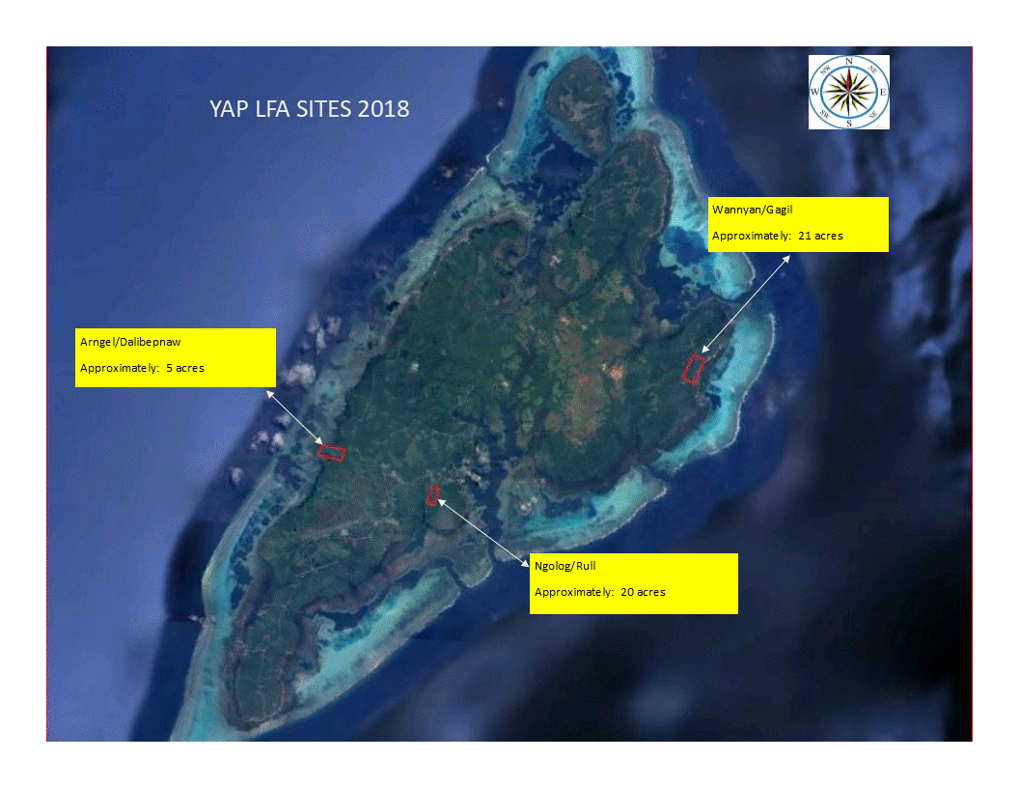
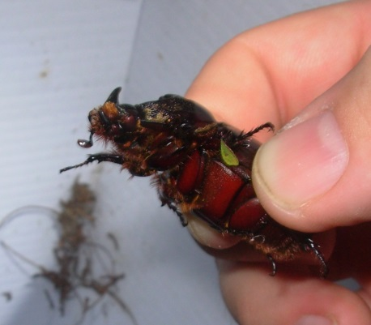
Coconut Rhinoceros Beetle (Oryctes rhinoceros)
J Stanford

9.0 Performance-based Invasive Species Work Plan
The following table, Table 2, describes on-going objectives of effective coordination for the YIST. Some of these objectives are carried over from the previous YIST SAP as many still need to be completed and some still require implementation. These objectives are based on selected invasive species for control and/or eradication activities, plus an additional objective to reduce the risk from additional pest organisms establishing in Yap State.

Table 2: YIST prevention, management and eradication programs
Terrestrial Invasive Species Eradication Program: African Tulip (Spathodea campanulata)
Goals | Objectives | Activities | Outputs/ Outcomes | Indicators | Lead/ Partners | Timeline | Funding
To protect and preserve terrestrial biodiversity | Eradication of African Tulip Tree from Yap State | Surveillance | Field surveys | Completed delimiting survey and associated maps | DAF YIST RISC SPC USFS Public | 2019 | TBD
 |  | Community engagement | Public informed and better cooperation | Number of communities participating |  | Implement 2019
 |  | One day/wk MOP-UP operation is conducted | Eradication of pest species | Species no longer present in Yap State |  | 2023
Terrestrial Invasive Species Eradication Program: (Lantana camara)
Goals | Objectives | Activities | Outputs/ Outcomes | Indicators | Lead/ Partners | Timeline | Funding
To protect and preserve terrestrial biodiversity | Lantana surveyed and controlled or eradicated if feasible | Surveillance | Mapping of infested areas | Number of areas mapped | DAF YIST RISC SPC USFS Public | 2020 | TBD
 |  | Community engagement | Public informed and better cooperation | Number of communities informed |  | Implement 2019
 |  | Treatment one day/wk conducted | Controlled or eradicated | Range of Lantana reduced or complete eradicated |  | 2023
Table 2 continued: YIST prevention, management and eradication programs
Terrestrial Invasive Species Management Program: “Paper Rose” (Operculina ventricosa); Bronze-Leafed Clerodendum or Februwari (Clerodendrum quadriloculare); “Cat’s Tail” Grass (Pennisetum polystachion); Merremia or Wachathngal (Merremia peltata); Wedelia or Susuwan’ (Wedelia trilobata); Giant Sensitive Plant or Rachloy’ ni Biech (Mimosa invisa)
Goals | Objectives | Activities | Outputs/ Outcomes | Indicators | Lead/ Partners | Timeline | Funding
To protect and preserve terrestrial biodiversity | Develop effective management strategies | Conduct research on control methods | Efficient control methods in place | Management strategies completed and control tools in place | DAF YIST RISC SPC USFS Public | 2019 | TBD
 | Understand extent of current ranges | Conduct delimiting surveys for all species | Known range extent for each species | Delimiting surveys completed for each species |  | 2021
 | Engage local communities in management efforts | Public awareness and community involvement | Public supports and actively cooperates with control effort | Number of communities involved |  | Implement 2019
 | Reduce ranges of at least 3 species | Implement management strategies | Decreased presence of 3 or more species | Reduced impacts from these species |  | 2023
Table 2 continued: YIST prevention, management and eradication programs
Terrestrial Invasive Species Eradication Program: Monitor lizard (Varanus indicus) and Rats (Rattus spp.)
Goals | Objectives | Activities | Outputs/ Outcomes | Indicators | Lead/ Partners | Timeline | Funding
To reduce impacts to natural resources and local communities | Community engagement | Awareness campaign | Communities engaged | Number of communities involved | UFCAP IC YIST | 2021 | $10K (possible GEF-6)
 | Eradicate monitor lizards and rats from Loosiep Island, Ulithi Atoll | Implement eradication plan | Loosiep monitor and rodent free | No monitors or rodents detectable on Loosiep island |  |  | $472 (funded by Darwin Initiate and OIA)
 | Survey and prioritize other islands for possible monitor and/or rodent eradication projects | Island feasibility study | Report on which islands eradications may be feasible | List of potential eradication sites |  | 2021
 |  | Prioritize sites and conduct surveys | Population surveys for target species at priority sites | List of prioritized sites |  | 2022
Terrestrial Invasive Species Management Program: Rat (Rattus spp.)
Goals | Objectives | Activities | Outputs/ Outcomes | Indicators | Lead/ Partners | Timeline | Funding
To protect and preserve terrestrial biodiversity, human health and welfare, and food security | By 2020 rodent control program in place in Yap Proper | Outreach and engagement in local communities and businesses | Community and businesses participating | Number of communities and businesses involved | DAF YIST RISC SPC USFS YINS Public DHS Yap EPA | 2020 | TBD
 | Reduce population of rats on Yap | Implement control program | Communities and businesses engaged in rodent control program | Reduced rodent encounters |  | 2023
Table 2 continued: YIST prevention, management and eradication programs
Invasive Species Prevention Program
Goals | Objectives | Activities | Outputs/ Outcomes | Indicators | Lead/ Partners | Timeline | Funding
To prevent impacts to natural resources and local communities | Establish an invasive species response capacity for Yap State | Early Detection Rapid Response and ICS training | Group of trained individuals and agencies in Yap | Number of trained team members and participating agencies | DAF YIST RISC SPC USFS YINS Public DHS Yap EPA | 2019 | $25,000
 |  | Emergency response plans in place | Updated BTS and CRB response plans; Generic response plans created | Emergency response plans
 |  | Awareness campaign | Increased engagement from visitors and residents | Numbers of presentations, posters, flyers, etc. |  |  | TBD
 |  | Public reporting systems in place and used | Advertised encounter hotline for public use and trained operator | Public use of reporting hotline
Table 2 continued: YIST prevention, management and eradication programs
Terrestrial Invasive Species Control Program: Feral Cats and Dogs
Goals | Objectives | Activities | Outputs/ Outcomes | Indicators | Lead/ Partners | Timeline | Funding
To protect and preserve terrestrial biodiversity, human health and welfare, and food security | A public education/ awareness program in place to decrease number of feral cats and dogs | Support yearly one-week animal clinics and submit proposals for a permanent state veterinary clinic | Healthier animals, increased public health and decreased number of feral cats and dogs | Fewer feral cats and dogs | DAF YIST RISC SPC USFS YINS Public COM DHS DPS Yap EPA | on-going through 2023 | $10K/yr
 |  | Develop awareness materials and conduct community meetings | Decreased number of feral cats and dogs through improved awareness | Number of awareness activities yearly
 |  | Conduct public awareness | Community participation | Number of communities involved
Aquatic Invasive Species Control Program: Tilapia (Oreochromis mossambicus)
Goals | Objectives | Activities | Outputs/ Outcomes | Indicators | Lead/ Partners | Timeline | Funding
To protect and preserve marine biodiversity by controlling and managing tilapia | Assess distribution and population | Conduct surveys | Better knowledge of distribution & population of tilapia | Number of surveys conducted | DAF YIST RISC SPC USFS MRMD Public DHS Yap EPA | 2019 | $50,000
 | Develop appropriate control mechanisms | Find and test different control methods | Control methods developed | Effectiveness of control methods developed |  | 2020
 | Public awareness program in place | Develop awareness materials and conduct community meetings | Decreased number of tilapia through improved awareness | Number of communities involved |  | Implement 2019
Table 2 continued: YIST prevention, management and eradication programs
Aquatic Invasive Species Control Program: Crown of Thorns (Acanthaster planci)
Goals | Objectives | Activities | Outputs/ Outcomes | Indicators | Lead/ Partners | Timeline | Funding
To protect and preserve marine biodiversity | Assess status of Crown of Thorns | Conduct surveys | Better knowledge of distribution & density | Number of surveys conducted | DAF YIST RISC SPC USFS MRMD Public DHS Yap EPA | 2019 | $20,000
 | Develop appropriate control mechanisms | Find and test different control methods | Control methods developed | Effectiveness of control methods developed |  | 2020
 | Public awareness program in place | Develop awareness materials and conduct community meetings | Decreased numbers through improved awareness | Number of communities involved |  | Implement 2019

10.0 Conclusion
The YIST SAP is an essential step towards addressing key threats and impacts to Yap’s terrestrial and aquatic habitats, human safety and welfare, and food security. It is the vision of YIST that “Yap will have a sustainable invasive species strategy and strengthened capacity to manage aquatic and terrestrial ecosystems, which will ensure the cultural, social and economic well-being these islands”. This plan directly acknowledges that invasive species are a critical issue to the future of our islands and people. Through collaboration between Yap state government, communities, local organizations, and partners, YIST aims to accomplish the goals and objectives outlined in this plan.

The YIST SAP is only as effective as the will to implement it and the funding to support it. It is anticipated that the Yap State leadership and communities will support this endeavor for the well-being of the people of Yap.

Endorsed by:

____________________________ _____________________________

Chairman, Council of Pilung Chairman, Council of Tamol

____________________________ _____________________________

Governor, Yap State Speaker, Yap State Legislature

