FSM Department of Environment, Climate Change and Emergency Management (FSM DECEM)
Mission Report

Subject: Assessment of Adaptation Fund (AF) Project Sites on Nukuoro and Kapingamarangi Islands

Duration of Mission: January 17 to 26, 2021

Travelers: Kohsak Keller Jr. – Adaptation Program Manager, DECEM
Morthy Solomon – AF Project Operations and Finance Officer (OFO), PNI State EPA & DECEM
Louis Sahle – Water Specialist, PNI PUC
Edson Joseph– PNI AF Project Local Engineer
Snyther Biza – GIS Program Manager, DECEM
Objectives
- Inspect the targeted public water infrastructures construction and improvement progress on Nukuoro and Kapingamarangi
- Collect geospatial data (GPS locations) and capture photos of the selected residential water infrastructures on Nukuoro and Kapingamarangi
- Interview some of the residential water tank owners whom the AF project had repaired their water tanks to get their feedback about the work and the project on Kapingamarangi
- Deliver the construction materials and tools for the construction and repairing work to the local coordinators on Nukuoro and Kapingamarangi

Trip Summary
DAY 1: Sunday January 17, 2021
This trip began departing at the Pohnpei Port Authority dock on Sunday January 17, 2021 at 6:00 pm. on FSM’s MS Caroline Voyager ship headed towards the southern islands in Pohnpei state. The mission team consists of 5 members and they are followed:
- Mr. Kohsak Keller Jr, the Adaptation Program Manager from DECEM,
- Mr. Morthy Solomon, the AF Project Operations and Finance Officer (OFO) from DECEM based at PNI EPA,
- Mr. Louis Sahle, the Water Specialist and Inspector from PNI PUC,
- Mr. Edson Joseph, the PNI AF Project Local Engineer, and
- Mr. Snyther Biza, the GIS program manager from DECEM.
DAY 2 & 3: Monday & Tuesday January 18 & 19, 2021 – Sapwuafik Island
On Monday morning, January 18, 2021 the ship arrived at Sapwuafik island and the offloading operation took 2 days, due to bad weather. The team’s mission was on Nukuoro and Kapingamarangi, so the team didn’t go onshore, thus spent a night on the ship. In the afternoon on Tuesday January 19, 2021 at about 4:00pm. the ship departed Sapwuafik island and headed south towards Nukuoro island.

DAY 4: Wednesday January 20, 2021 – Nukuoro Island
In the late morning on Wednesday January 20, 2021, the ship arrived at Nukuoro Island. Though the seas were rough with big waves and strong wind, the ships’ motor-boat managed to bring the team on shore, where we first met and briefed the mayor representative and some members of the community of our survey and assessment activities. The team members that went on shore on Nukuoro were Jun Keller, Louis Sahle, Edson Joseph, and Snyther Biza, to do the inspection of the targeted public water infrastructures currently under construction and also surveyed the selected residential water tanks that the AF project will be repairing (GPS coordinates and photos taken, inspect condition).

For the public water infrastructure inspection work on Nukuoro, out of 4 public water wells that the AF project had committed to repair, 1 is currently under construction with the walls and the base completed. The remaining construction work for this water well include the installation of the water pump and the cover and also the fence around it. Also, on Nukuoro, out of 3 public water tanks that the AF project had committed to repair, 1 is currently under construction with the base completed. The remaining work for this public water tank is the installation of the tank on the base with the fence around it, and the water gutters on the church building for the water catchment system for the tank. The inspection work was done by the water specialist and inspector Mr. Louis Sahle and the local engineer Mr. Edson Joseph. Shown below are the pictures for the public water well and the public water tank under construction on Nukuoro.

AF Public Water Well under construction on Nukuoro (Before and After pictures)
Before Picture – taken on May 2020  Before construction | After Picture – taken on January 2021  After construction of the base and wall of the water well
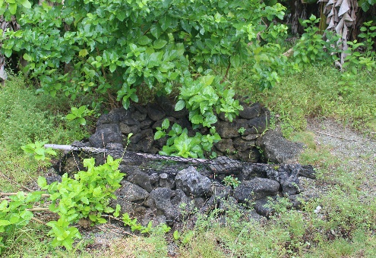 | 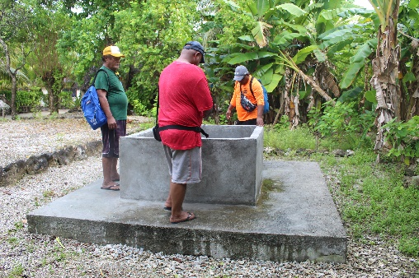 | 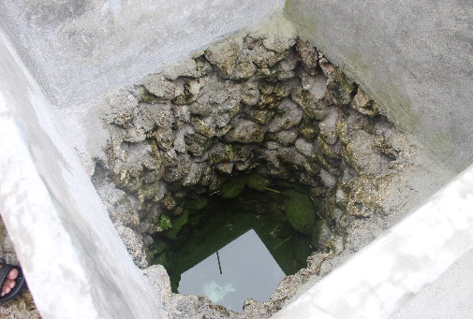

AF Public Water Tank under construction on Nukuoro (Before and After pictures)
Before Picture – taken on May 2020  Before construction | After Picture – taken on January 2021  After construction of the base
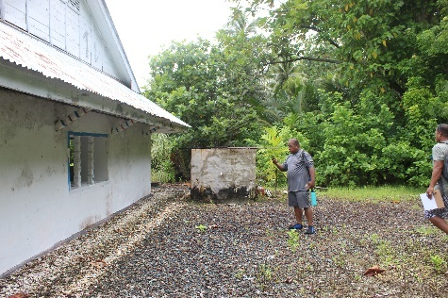 | 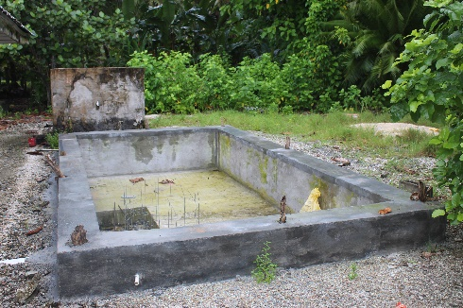 | 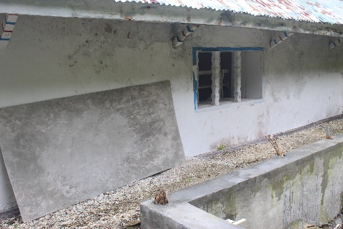

For the GPS data and photo collection work on Nukuoro, 21 selected residential water tanks were captured with their GPS coordinates recorded. These residential water tanks were selected because they were either leaking from cracks, missing water catchment, and broken faucet. Shown below are some of the 21 selected residential water tanks that were assessed. Also see attached to this report a map showing locations of the surveyed residential water tanks during this mission. The other attribute information for these surveyed water tanks such as water tank measurements, capacity, detail condition, and usage were provided by the local coordinator from Nukuoro Mr. Arakuchi Fred.

Some of the Residential Water Tanks surveyed that the AF project will be repairing on Nukuoro:
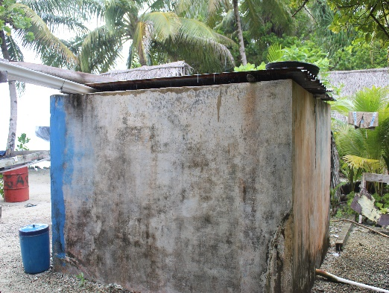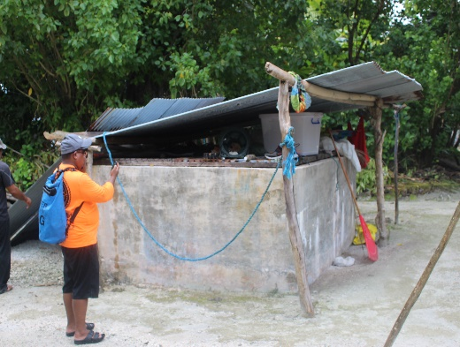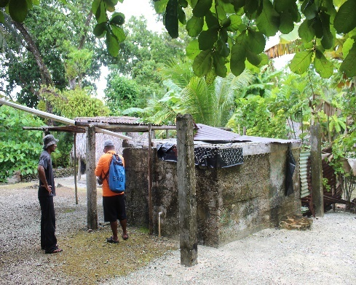
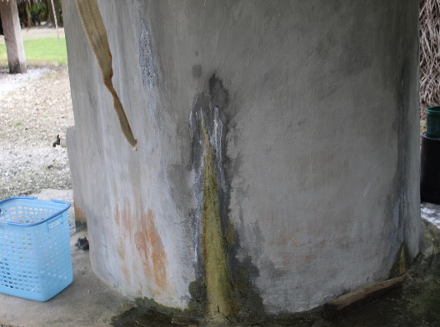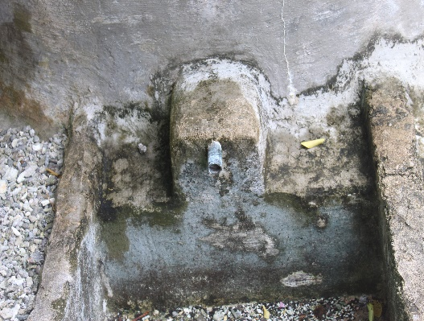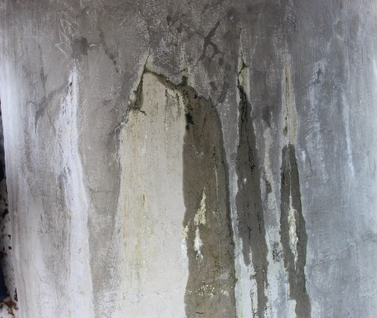
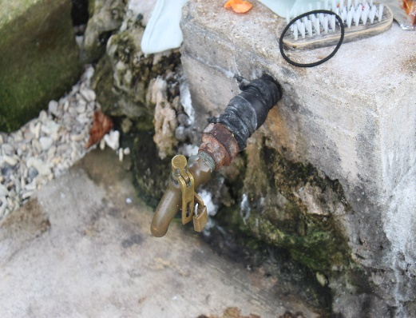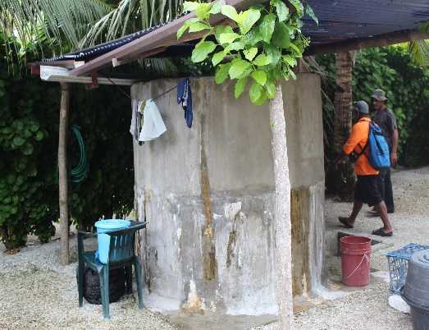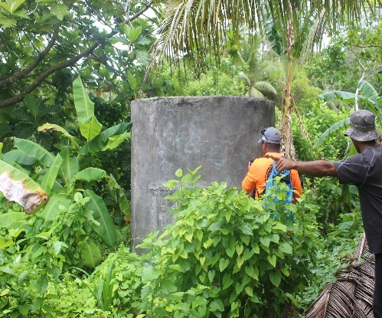
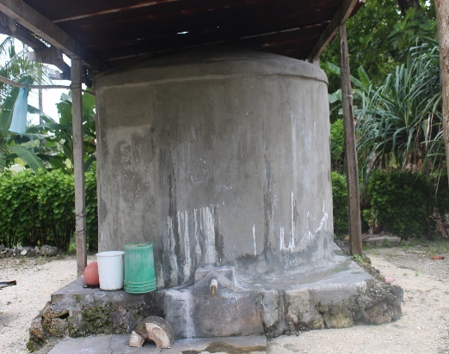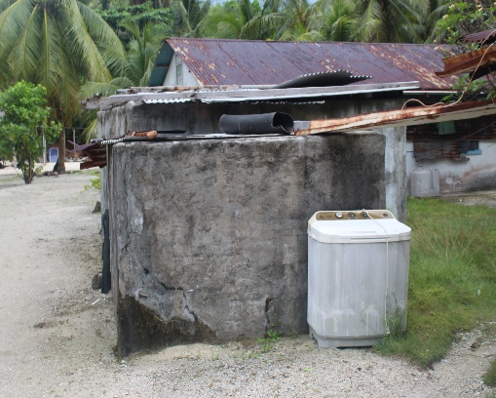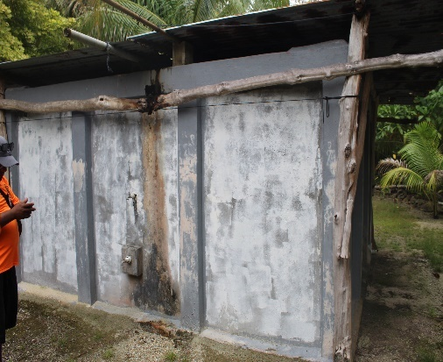

For the delivery of the construction materials and tools to Nukuoro, Mr. Morthy Solomon stayed on the ship to make sure the construction materials and tools for Nukuoro AF project were delivered from the ship. On shore, the materials were delivered and stored at the municipal warehouse. Shown below are some of the pictures taken during this mission. There was a great effort of community support for this activity on Nukuoro.

Construction materials delivered to Nukuoro:
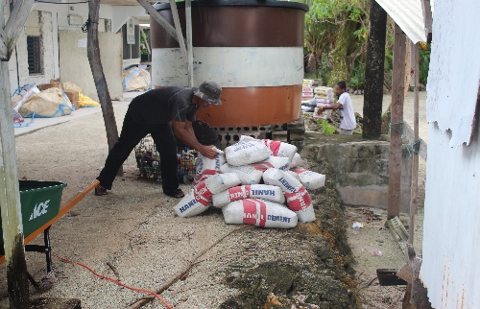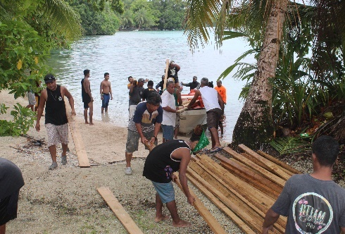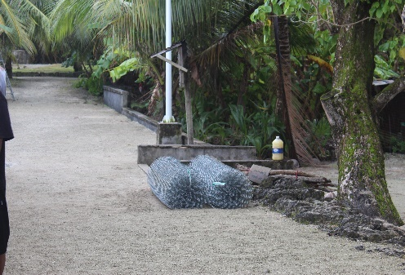
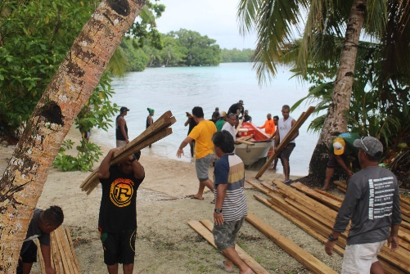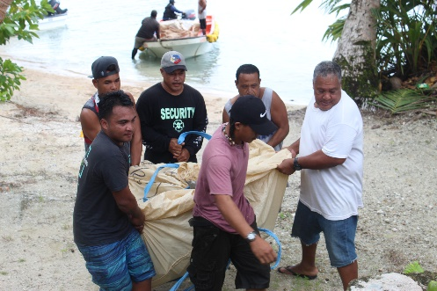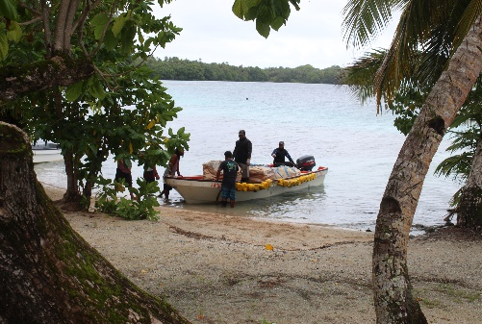

The climate change awareness posters were also delivered and distributed to the municipal government, school and the community. Shown below is the climate change awareness poster posted on the municipal government building with the chief rep of Nukuoro.
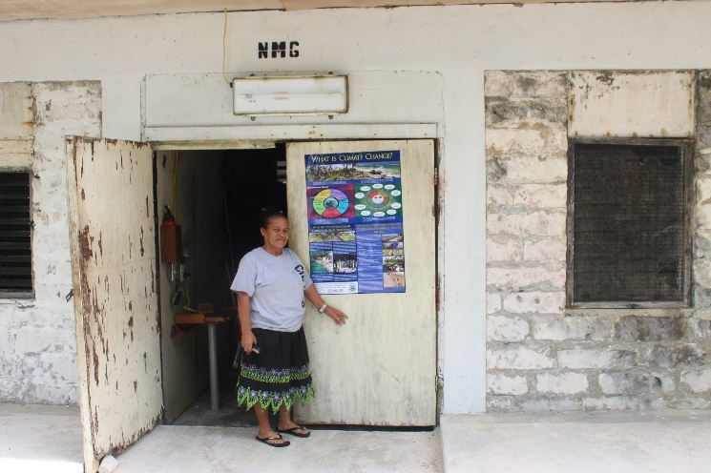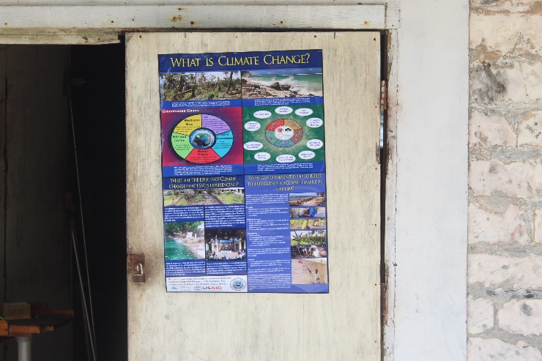

DAYS 5-7: Thursday to Saturday January 21-23, 2021 – Kapingamarangi Island
In the late morning on Thursday January 21, 2021, the ship arrived at Kapingamarangi island. Mr. Louis Sahle went in first and inspect the AF public water wells (see pictures below), while the others stayed on the ship and assisted the delivery of the construction materials and tools. It was raining during that time so Mr. Keller and Mr. Biza couldn’t go on shore to do the geospatial data collection and to take pictures of the residential water tanks. In the evening, after all construction materials and tools for the AF project were delivered, the team went on shore and spent a night on the island.

Some of the AF Public Water Wells on Kapingamarangi:
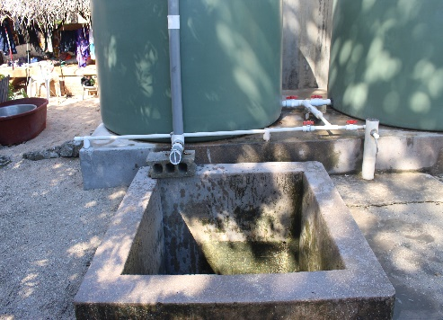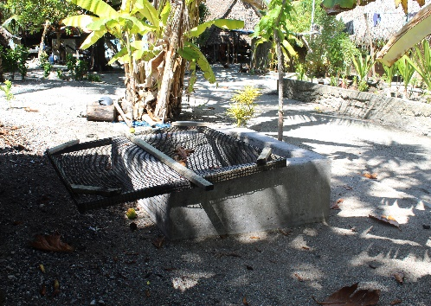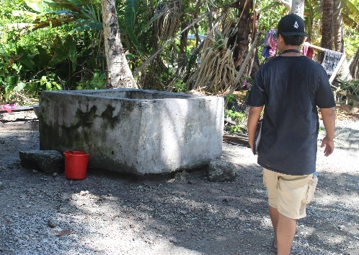

On Friday January 22, 2021, the team surveyed a total of 33 water tanks that the AF project on Kapingamarangi had repaired. The survey includes the inspection of the water tanks repaired work, collection of GPS coordinates and pictures of each repaired tank, and the water tank owner’s interviews. Out of the total 33 repaired water tanks, 19 residential water tanks were repaired on Souhou island, 9 residential water tanks were repaired on Welua island, and 5 public water tanks were also repaired. See pictures below of some of the repaired residential water tanks on Souhou island and on Welua island. 5 interviews were also recorded during the time the survey was taking place. The interviews will be shared in a different file as audio records.
Some of the Residential Water Tanks repaired by AF project on Kapingamarangi:
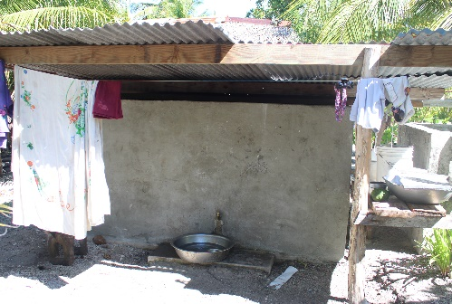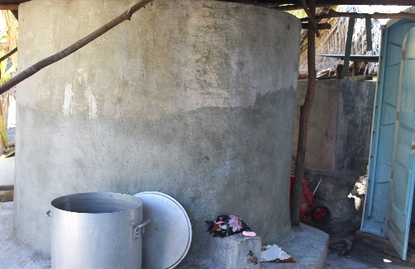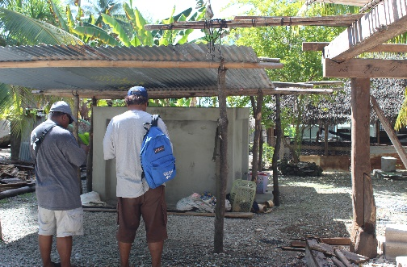
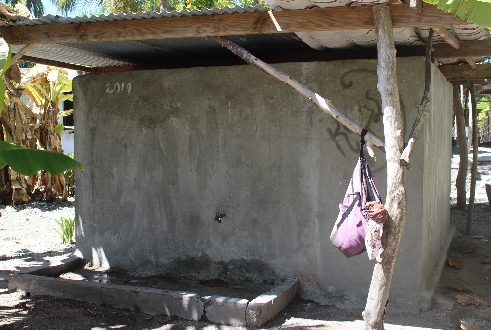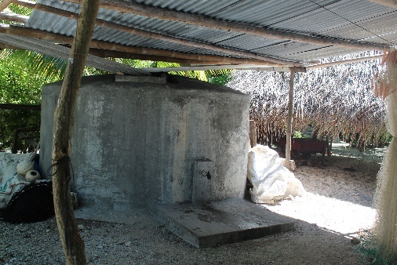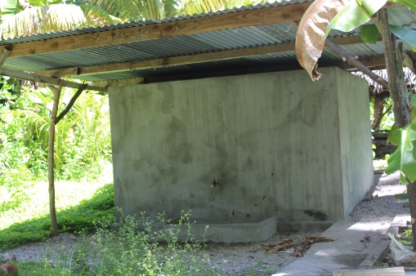
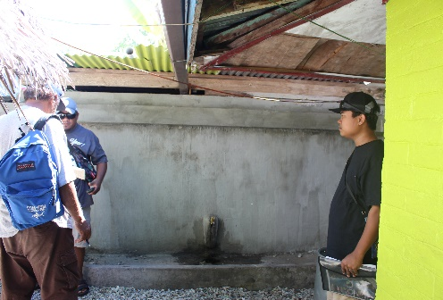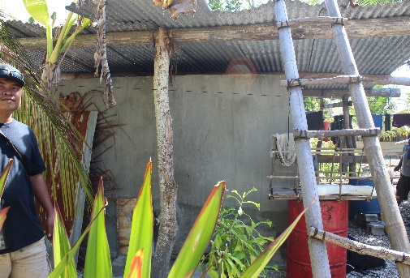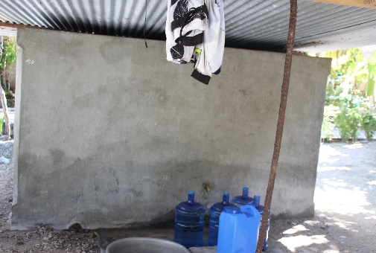

On Saturday January 23, 2021, after the ship completed its backloading it departed Kapingamarangi at about 4:00pm and headed towards Nukuoro island.
DAYS 8-10: Sunday & Monday January 24-26, 2021 – Nukuoro Island & Tekehtik, Pohnpei
At 9:00 a.m. on Sunday January 24, 2021, the ship arrived at Nukuoro. The ship spent the whole day at Nukuoro backloading the cargos and the passengers. At about 6:00 p.m. same day, the ship departed Nukuoro and headed straight back to Tekehtik, Pohnpei. At 9:00 p.m. on Monday January 25, 2021, the ship arrived at Pohnpei Port Authority dock in Tekehtik, and the passengers had to spent a night on the ship and offboard next morning Tuesday January 26, 2021, because the operations at the port closes at 6:00pm. This trip was completed without any complications. Weather was an issue at times with several heavy rains and big waves between Nukuoro and Kapingamarangi, but everything went well and the team returned home safely.
Mission Team
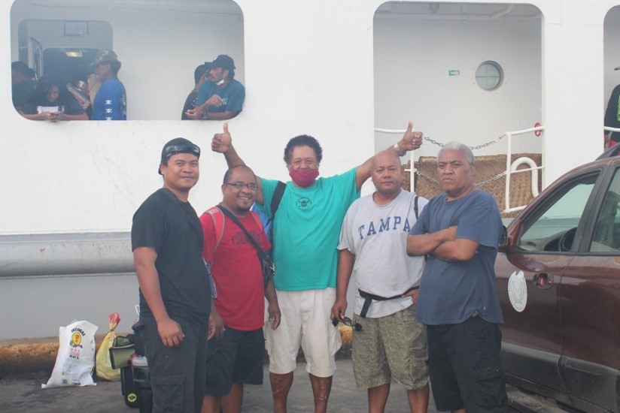

Mission Findings and Recommendations
Mission Findings:
- On Nukuoro, 21 residential water tanks were selected to be repaired by the AF project, thus were surveyed and mapped during the mission. These tanks were selected because they’re currently in use but in poor conditions. Most of the tanks were cracked and with poor water catchment system, some with broken faucet, and others missing faucet and catchment. These tanks were also selected because the structure is concrete and can be easily repaired. Refer to table 1 on page (8) for the assessment summary results of the residential water tanks on Nukuoro conducted during the trip.
- On Nukuoro, 2 public water infrastructures (1 water well and 1 water tank) are currently under construction. The water well has completed its base and the wall, yet to install the water pump, cover and the fence around it. The water tank has completed its base, yet to install the tank and the fence around it.
- On Kapingamarangi, total of 33 water tanks had already been repaired by the AF project, 28 were residential water tanks and 5 were public water tanks. All repaired tanks are in good condition with most of the tanks has its own stand-alone water catchment system and only a few use houses nearby as its water catchment, and all are currently in use, thus were surveyed and mapped during this mission. These tanks have collected some rainwater, but still not enough due to not so much rain on the island. Refer to table 2 on pages (9 & 10) for the assessment summary results of the 28 residential water tanks on Kapingamarangi conducted during the trip.
- On Kapingamarangi, 4 public water wells are currently under construction. The walls are repaired, yet to construct the base, install water pumps and cover and fence around each water well. 5 public water tanks were also repaired by AF project on Kapingamarangi (2 at the Protestant church, 1 at the Catholic church, 2 at 2 communities, 1 on Souhou island and 1 on Welua island).
- On Kapingamarangi, there were other residential water tanks that had been selected to be repaired however waiting commitment from tank owners, thus were not surveyed and mapped during this mission. Some of these tanks are on Souhou island, some on Welua island, and others are on the other nearby islands where some people are currently residing.
- Refer to Maps 1 and 2 attached for the locations of the Residential Water Tanks for AF project repair support on Nukuoro (Map 1) and Kapingamarangi (Map 2). Google maps for both assessments were also generated using the data collected from the assessments and will be shared for office use and AF project use.
- Overall, the AF project on both Nukuoro and Kapingamarangi is ongoing, with more project activities on Kapingamarangi than on Nukuoro. On Kapingamarangi, most of the residential tanks, and public water infrastructures are repaired, whereas on Nukuoro, only 2 public water infrastructures are under construction and yet to repair the selected residential water tanks.
Mission Recommendations:
- For visibility of the AF project, need to have AF project logo at the public water infrastructure sites on both Nukuoro and Kapingamarangi.
- EPA’s portable water testing kit needs to test the residential water systems on Nukuoro and Kapingamarangi for E-coli, total coliform and turbidity before and after repairing the water tanks.

Table 1: Assessment Summary of the Selected Residential Water Tanks on Nukuoro island (To be Repaired by AF Project)
Site # | Island | Tank Owner | X-Coordinate | Y-Coordinate | Assessment Date | Water Storage Structure Assessment
 |  |  |  |  |  | # of Water Storages | Tank Structure Material | Tank Measurements (ft) | Total Capacity (US gallon) | Structure Condition | Comments & Recommendations
1 | Nukuoro | Tenny Leopold | 154.9691 | 3.833617 | 1/20/21 | 1 | Concrete | L5’xW5’’xH4’ | 748.05 | Cracked at the side and leaking faucet | Need repairing
2 | Nukuoro | Carson/Triny | 154.9699 | 3.834173 | 1/20/21 | 1 | Concrete |  |  | Cracked and poor catchment | Need repairing
3 | Nukuoro | Adelaide Henry | 154.9702 | 3.834412 | 1/20/21 | 1 | Concrete | L8’xW8’xH8’ | 3830.03 | Cracked and poor catchment | Need repairing
4 | Nukuoro | Jacob R | 154.9708 | 3.835352 | 1/20/21 | 1 | Concrete |  |  | Cracked and rusted cover | Need repairing
5 | Nukuoro | Tenned Jacob | 154.972 | 3.838261 | 1/20/21 | 1 | Concrete | L6’xW6’xH5’ | 1346.49 | Cracked at the side | Need repairing
6 | Nukuoro | Mideon Ezekias | 154.9721 | 3.83908 | 1/20/21 | 1 | Concrete | D6’xH5’ | 1057.00 | Cracked and poor catchment | Need repairing
7 | Nukuoro | Ambelihna L | 154.972 | 3.839443 | 1/20/21 | 1 | Concrete |  |  | Broken faucet | Need repairing
8 | Nukuoro | Etaina E | 154.9723 | 3.839794 | 1/20/21 | 1 | Concrete |  |  | Cracked at the side | Need repairing
9 | Nukuoro | Kadrihna S | 154.9723 | 3.840378 | 1/20/21 | 1 | Concrete |  |  | Leaking faucet | Need repairing
10 | Nukuoro | Hellen A | 154.9721 | 3.840677 | 1/20/21 | 1 | Concrete |  |  | Cracked at the side | Need repairing
11 | Nukuoro | Gatterson Sebastian | 154.972 | 3.841705 | 1/20/21 | 1 | Concrete | D6’xH5’ | 1057.00 | Cracked at the side poor catchment | Need repairing
12 | Nukuoro | Bermino Retinan | 154.9724 | 3.8421 | 1/20/21 | 1 | Concrete | D8’xH6’ | 2254.93 | Rusted faucet and poor catchment | Need repairing
13 | Nukuoro | Jano Rudolph | 154.9724 | 3.842713 | 1/20/21 | 1 | Concrete | D8’xH4’ | 1503.29 | Cracked at the side | Need repairing
14 | Nukuoro | Lambert Ezekias | 154.9721 | 3.843276 | 1/20/21 | 1 | Concrete | D6’xH5’ | 1057.00 | Cracked and missing catchment and faucet | Need repairing
15 | Nukuoro | Harson Henry (1) | 154.9718 | 3.844144 | 1/20/21 | 1 | Concrete | L12’xW11’xH3’ | 2962.29 | Cracked and rusted catchment | Need repairing
16 | Nukuoro | Harson Henry (2) | 154.9718 | 3.844154 | 1/20/21 | 1 | Concrete | L8’xW6’xH2’ | 718.13 | Cracked and rusted catchment | Need repairing
17 | Nukuoro | Godaro Lekka | 154.9716 | 3.844444 | 1/20/21 | 1 | Concrete | D8’xH6’ | 2254.93 | Cracked at the side | Need repairing
18 | Nukuoro | Senard Leopold (1) | 154.9718 | 3.844829 | 1/20/21 | 1 | Concrete | D5’xH5’ | 734.03 | Cracked and rusted catchment | Need repairing
19 | Nukuoro | Senard Leopold (2) | 154.972 | 3.845079 | 1/20/21 | 1 | Concrete | L13’xW13’xH4.7’ | 5941.78 | Cracked and rusted catchment | Need repairing
20 | Nukuoro | Berney C (1) | 154.9716 | 3.83675 | 1/20/21 | 1 | Concrete |  |  | Cracked and rusted catchment | Need repairing
21 | Nukuoro | Berney C (2) | 154.9728 | 3.836083 | 1/20/21 | 1 | Concrete |  |  | Cracked and missing faucet | Need repairing

Table 2: Assessment Summary of the Repaired Residential Water Tanks on Kapingamarangi island (Already Repaired by AF Project)
Site # | Island | Tank Owner | X-Coordinate | Y-Coordinate | Assessment Date | Water Storage Structure Assessment
 |  |  |  |  |  | # of Water Storages | Tank Structure Material | Tank Measurements (inches) | Total Capacity (US gal) | Structure Condition | Comments & Recommendations
1 | Kapinga | Usast Ngage | 154.8076 | 1.077079 | 1/22/21 | 1 | Concrete | L-123” sq. H-67” | 4,388.07 | Repaired tank with catchment; good condition | In-use
2 | Kapinga | Rensper Coobai | 154.8077 | 1.077224 | 1/22/21 | 1 | Concrete | L-124” sq. H-60” | 3,993.77 | Repaired tank with catchment; good condition | In-use
3 | Kapinga | Christian Dai Koopai | 154.8075 | 1.077293 | 1/22/21 | 1 | Concrete | L-125” sq. H-64” | 4,329.00 | Repaired tank with catchment; good condition | In-use
4 | Kapinga | Kuine Tagalu | 154.8074 | 1.077409 | 1/22/21 | 1 | Concrete | L-137” sq. H-68” | 5,525.07 | Repaired tank with catchment; good condition | In-use
5 | Kapinga | Arkat Tagaluuu | 154.8077 | 1.077552 | 1/22/21 | 1 | Concrete | L-124” sq. H-75” | 4,992.21 | Repaired tank with catchment; good condition | In-use
6 | Kapinga | Maika NgeiTagalu | 154.8077 | 1.077718 | 1/22/21 | 1 | Concrete | L-169” sq. H-75” | 9,273.05 | Repaired tank with catchment; good condition | In-use
7 | Kapinga | Usast Diloki | 154.8078 | 1.07752 | 1/22/21 | 1 | Concrete | L-136” sq. H-72” | 5,764.99 | Repaired tank with catchment; good condition | In-use
8 | Kapinga | Harvy Diloki | 154.8079 | 1.077685 | 1/22/21 | 1 | Concrete | D-94” H-70” | 2,101.90 | Repaired tank with catchment; good condition | In-use
9 | Kapinga | Tomicy Duangage | 154.8083 | 1.078169 | 1/22/21 | 1 | Concrete | L-142” sq. H-67” | 5,848.43 | Repaired tank with catchment; good condition | In-use
10 | Kapinga | Steven Malali | 154.808 | 1.078604 | 1/22/21 | 1 | Concrete | D-120” H-69” | 3,376.52 | Repaired tank with catchment; good condition | In-use
11 | Kapinga | Dosiko Ngeia Heleu | 154.8079 | 1.078448 | 1/22/21 | 1 | Concrete | L-90” sq. H-68” | 2,384.42 | Repaired tank with catchment; good condition | In-use
12 | Kapinga | Bondaig Ngeia Heleu | 154.8077 | 1.078355 | 1/22/21 | 1 | Concrete | L-104” sq. H-68” | 3,183.93 | Repaired tank with catchment; good condition | In-use
13 | Kapinga | Twinson Dua Ngeia | 154.8079 | 1.078756 | 1/22/21 | 1 | Concrete | D-75” H-68” | 1,299.84 | Repaired tank with catchment; good condition | In-use
14 | Kapinga | Sapuro Malali | 154.8081 | 1.078739 | 1/22/21 | 1 | Concrete | L-124” sq. H-72” | 4,792.52 | Repaired tank with catchment; good condition | In-use
15 | Kapinga | Yoster Ngei | 154.8074 | 1.078903 | 1/22/21 | 1 | Concrete | D-130” H-72” | 4,135.01 | Repaired tank with catchment; good condition | In-use
16 | Kapinga | Dison Dai Ngeia | 154.8071 | 1.079051 | 1/22/21 | 1 | Concrete | D-115” H-67” | 3,011.12 | Repaired tank with catchment; good condition | In-use
17 | Kapinga | Betwel Dai Ngeia | 154.8072 | 1.078757 | 1/22/21 | 1 | Concrete | L-140” sq. H-66” | 5,600.00 | Repaired tank with catchment; good condition | In-use
18 | Kapinga | Kaison Dai | 154.8073 | 1.07875 | 1/22/21 | 1 | Concrete | L-135” sq. H-72” | 5,680.52 | Repaired tank with catchment; good condition | In-use
19 | Kapinga | Robert Dai | 154.8074 | 1.078052 | 1/22/21 | 1 | Concrete | D-76” H-65” | 1,275.85 | Repaired tank with catchment; good condition | In-use
20 | Kapinga | Scothkey Ton Di Bilid | 154.8077 | 1.080828 | 1/22/21 | 1 | Concrete | L-136” sq. H-71” | 5,684.92 | Repaired tank with catchment; good condition | In-use
21 & 22 | Kapinga | Berry Talai (2 Tanks) | 154.8085 | 1.081468 | 1/22/21 | 2 | Concrete | D-126” H-69” | 3,722.61 | Repaired tank with catchment; good condition | In-use
23 | Kapinga | Dandy Di Adu Kene 1 | 154.8056 | 1.083268 | 1/22/21 | 1 | Concrete | D-126” H-70 | 3,776.56 | Repaired tank with catchment; good condition | In-use
24 | Kapinga | Dandy Di Adu Kene 2 | 154.8057 | 1.08316 | 1/22/21 | 1 | Concrete | L-80” sq. H-75” | 2,077.92 | Repaired tank with catchment; good condition | In-use
25 | Kapinga | Dandy Dai Alawa | 154.8061 | 1.082706 | 1/22/21 | 1 | Concrete | L-84” sq. H-73” | 2,229.82 | Repaired tank with catchment; good condition | In-use
26 | Kapinga | Rubino Agaidai | 154.8065 | 1.081952 | 1/22/21 | 1 | Concrete | L-123” sq. H-72” | 4,715.53 | Repaired tank with catchment; good condition | In-use
27 | Kapinga | Sakius Agaidai | 154.8066 | 1.081905 | 1/22/21 | 1 | Concrete | D-7’ H-9’ | 2,589.64 | Repaired tank with catchment; good condition | In-use
28 | Kapinga | Jestino Ngaage | 154.8071 | 1.080441 | 1/22/21 | 1 | Concrete | L-150” sq. H-67” | 6,525.97 | Repaired tank with catchment; good condition | In-use

Map 1: Nukuoro Selected Residential water tanks (To be Repaired by AF)
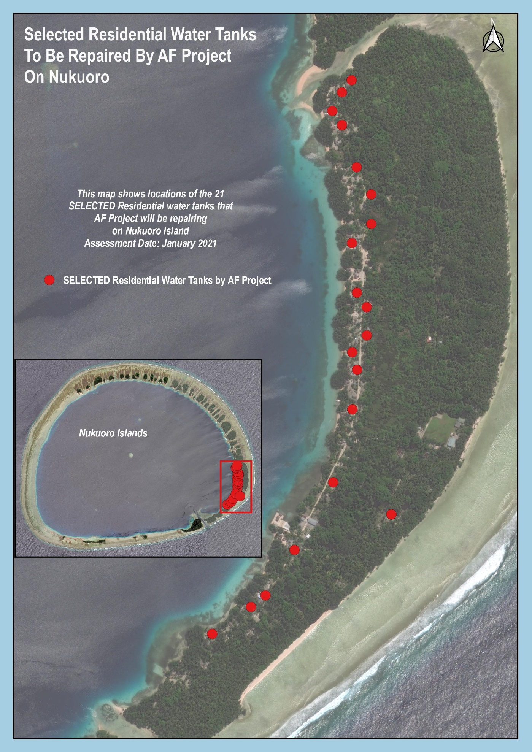
Map 2: Kapingamarangi Residential water tanks (Already Repaired by AF)
