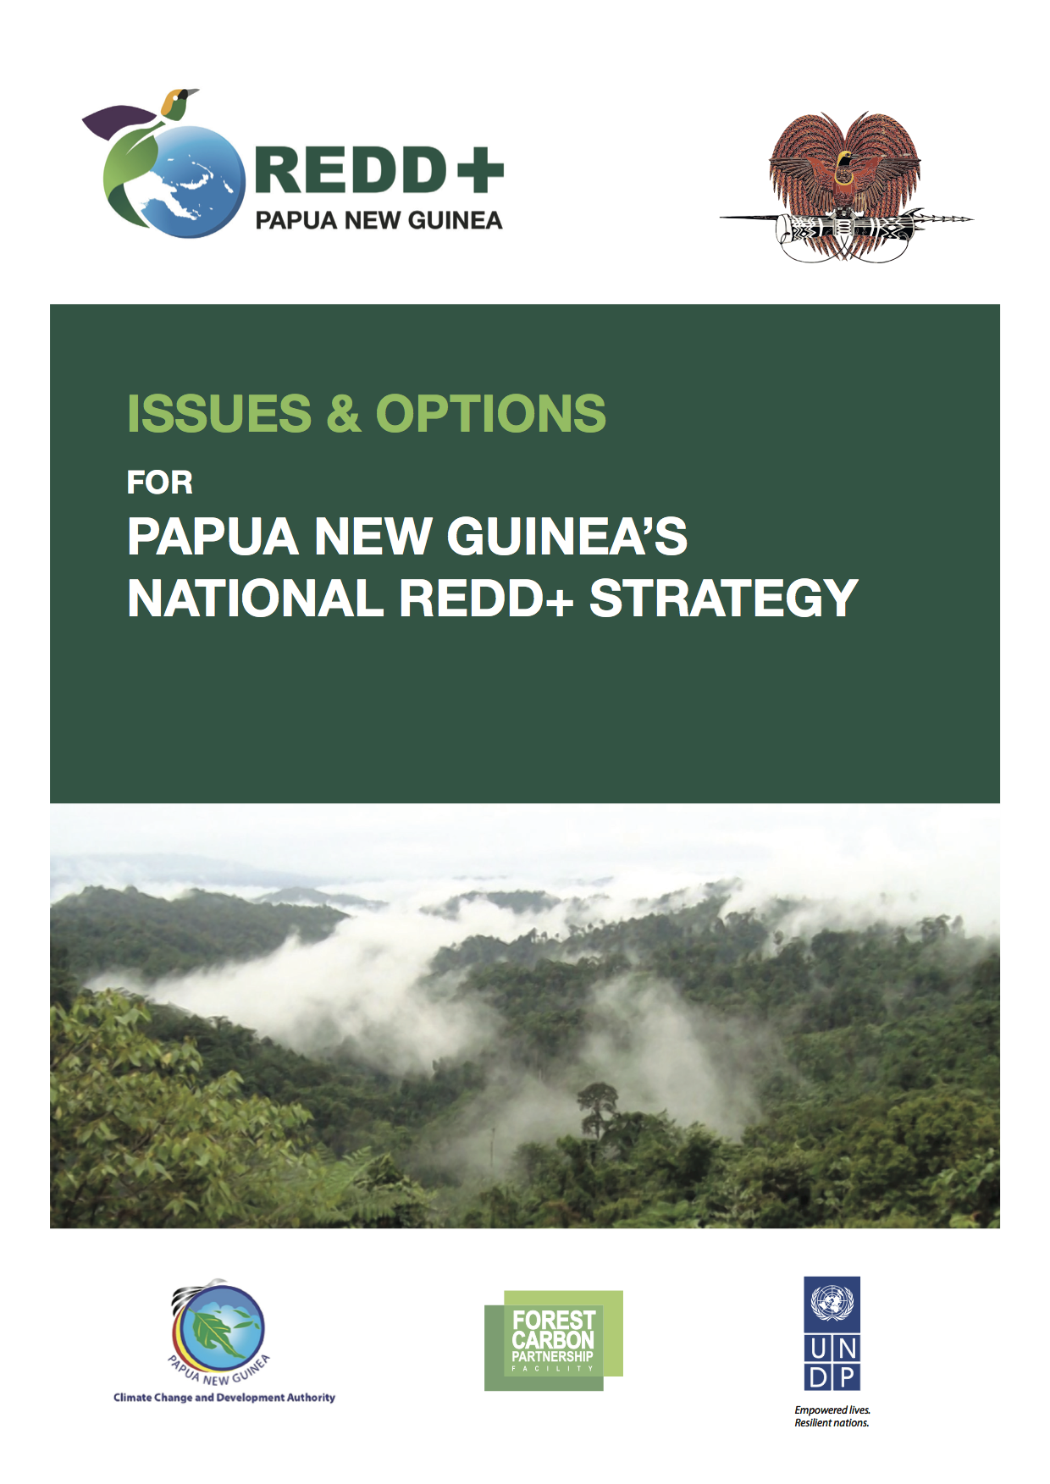

Issues and Options: Summary of Decision Areas and Actions

To engage in REDD+ under the UNFCCC countries must develop four core components: a National REDD+ Strategy, a Forest Reference Emission Level, a National Forest Monitoring System and a Safeguards Information System.
Four Core Components of REDD+

The National REDD+ Strategy is at the centre of these components. It sets out:
- Why the country is engaging in REDD+ (a country’s vision for REDD+);
- What actions will be undertaken to achieve this (policies and measures); and
- How those activities will be achieved (the institutional arrangements and financing).

The process of developing a National REDD+ Strategy is both influenced by, and will influence, the other three components. For example, the national vision for REDD+ (in the strategy) will be influenced by information on trends in forest cover across the country (the FREL); forest monitoring information (NFMS) will be influenced by which activities will be implemented; and safeguards to ensure that REDD+ does no harm (the SIS) will be influenced by the REDD+ activities that are implemented.

This ‘Issues and Options’ paper marks the first step towards the development of PNG’s National REDD+ Strategy, a process that is being centrally coordinated by the CCDA. The paper sets out proposals for the overall framework for REDD+ in PNG (the vision, scope and scale of REDD+) and aims to initiate discussion on priority Policies and Measures (PAMs) to address the drivers of forest cover change.

Vision

PNG needs a clear vision of what it wants to achieve through REDD+ implementation to guide decision making. This vision should be based on the nature of the country’s forests and be grounded in national development goals and objectives.

Based on PNG’s high forest cover, customary landownership and developing economy, as well as existing national development commitments including Vision 2050 and StaRS, it is proposed that the vision be based on a number of core principles including:

- REDD+ should be a catalyst for change – REDD+ finance and technical support will strengthen existing efforts for a sustainable forest and environment sector to achieve real change.
- REDD+ should focus on land use decision-making by communities – customary landowners are central to land and forest management and need to be supported, through both provision of livelihood options and information on different land uses, to make informed decisions on land management.
- REDD+ should focus on equality – REDD+ actions should help strengthen the rural economy and the economic opportunities of communities.
- REDD+ should focus on livelihood security – REDD+ actions should help to safeguard communities from environmental and economic shocks.
- REDD+ should focus on sustainability – REDD+ actions should help to ensure the sustainable use of resources and the safeguarding of the environment for future generations.

Based on these principles, a clear vision for REDD+ in PNG can be developed to help guide the creation of a National REDD+ Strategy.

REDD+ Vision: Proposed Actions:
Finalise a national vision for REDD+ that supports development objectives as well as climate change mitigation objectives of the country (INDC, CCDAP, etc.), and sets clear sectoral and cross-sectoral goals and commitments. Ensure that decision-making structures are in place to implement that vision.

- Establish a National REDD+ Steering Committee
Establish a senior level cross-sectoral (PNGFA, CCDA, CEPA, DAL, DNPM) coordination committee, chaired by CCDA, to guide REDD+ implementation.

- Finalise REDD+ Principles and Vision
The REDD+ Technical Working Group should review, develop and finalise a national vision for REDD+ and core principles that will be presented to the REDD+ Steering Committee for approval.

Scope of REDD+
PNG’s Priority Drivers:
Unsustainable Logging
- Impacting 5.4mill ha of forest
- Harvesting of 5.1mill m3 timber in 2014
- Estimated emissions between 15-80mill tCO₂ pa

Family Agriculture
- Impacting 3.5mill ha of forest
- Increase linked to rapid population growth (2.7%)
- Estimated emissions 15-35mill tCO₂ pa

Commercial Agriculture
- Impacting 0.66mill ha
- 5mill ha under SABLs (most for oil palm)

The scope refers to the REDD+ activities that PNG will implement. It should be based on the priority drivers of forest cover change. In PNG the following activities are proposed:

- Reduced Deforestation – to reduce the impact of land clearing for commercial and family agriculture.
- Reduced Forest Degradation – to address unsustainable logging and family agriculture.
- Enhancement of Forest Carbon Stocks – to increase forest areas.

REDD+ Scope: Proposed Actions:
A number of actions are needed to finalise the scope of REDD+ in PNG and continue to strengthen coordination across sectors and across elements of REDD+. These include:

- Agree on priority drivers of forest cover change
Review multiple data sources and agree and prioritise drivers of forest cover change that need to be addressed.

- Agree on the scope of REDD+ in PNG
Key stakeholders to agree on which REDD+ activities PNG will implement.

- Maintain and strengthen coordination across sectors and stakeholder groups:
Having a scope that will require action across a number of sectors requires close cross sector planning and management. It will thus be important to maintain and strengthen the operation of cross-sectoral and multi-stakeholder coordination bodies including the REDD+ and MRV/FREL Technical Working Groups.

Scale

The scale of REDD+ refers to the geographical area across which REDD+ actions will be implemented and monitored. Countries implementing REDD+ under the UNFCCC must ultimately aim for national scale implementation, though subnational approaches can be adopted as an interim measure. Consideration should be given to the distribution and diversity of forests, and to the nature of the drivers of forest cover change.

PNG will adopt a national scale approach to REDD+ implementation. The country has high forest cover with drivers of forest cover change acting across the country. Actions to address these drivers are needed at national, provincial and local levels.

In order to optimise the use of resources a number of priority areas (e.g. areas of high deforestation and/or forest degradation) will be targeted to both 1) demonstrate different approaches and 2) deliver maximum emissions reduction impact for the available investments.

These demonstration areas will operate within the framework of national coordination, institutional and monitoring arrangements, and take place at appropriate administrative scales to allow for REDD+ policies and measures to be integrated into government planning and implementation processes. Based on the on-going decentralisation process in PNG and the geographical and administrative scale required to demonstrate integrated approaches to emissions reductions, demonstration actions should occur at the provincial level.

REDD+ Scale: Proposed Actions:

- Completion of PNG’s Initial National FREL
PNGFA are working to complete the national FREL by the end of 2016. This work provides the basis for the national approach to REDD+ implementation.

- Prioritisation of demonstration areas
There is a need to prioritise areas in which to demonstration REDD+ actions. This will be done by assessing potential provinces against a number of objective criteria (e.g. rates of deforestation / degradation, levels of existing carbon stock, potential future drivers, and logistical feasibility) to identify areas in which maximum impact on reducing emissions can be achieved. This work should be initiated by the REDD+ TWG based on the recommendations from the Issues & Options paper, with final agreements being made under the National REDD+ Steering Committee. The first step is to determine the selection criteria (and weightings, as appropriate) for prioritizing provinces.

Potential Policies and Measures (PAMs)

To implement REDD+, PNG will identify a number of PAMs that:
- Are in line with PNG’s selected scope and scale for REDD+ implementation;
- Address the priority drivers of forest cover change;
- Consider existing national development goals and strategies.

The current document identifies a number of potential PAMs around which further consultation, assessment and prioritisation is required. These are organised by the drivers of forest cover change that they address with a number of cross-cutting PAMs also identified.

Driver of Emissions from Deforestation: Commercial Agriculture
Commercial agriculture currently occupies a relatively small land area in PNG, however over 5mill ha of land has been allocated for agricultural concessions.

Many of these concessions are allocated for oil palm but are not guided by a coordinated sector development strategy or targeted geographical plan to maximise effectiveness. Many also appear poorly planned with limited potential for sustainable investment. Their allocation has also been linked to poor coordination between key agencies and stakeholders resulting in a lack of effective due diligence and application of safeguards.

Strengthening strategic leadership, coordination and capacity within the sector will help to address such risks, while utilising a range of financial instruments can also help to guide private sector investment to ensure sustainability. Based on these concepts the following PAMs are proposed:

- Development and implementation of an oil palm policy – policy will guide palm oil development in PNG, including potential standards and targets.
- Establishment of a multi-stakeholder sector coordination mechanism – to improve coordination and communication between key stakeholders within the sector.
- Modification of tariffs, and subsidies to support certified / sustainable agricultural production - to increase incentives for sustainable commercial agricultural production.
- Strengthen capacity of communities and landowners to engage in commercial agriculture and negotiate contracts – to increase landowner capacity to manage development on customary land.

Driver of Emissions from Deforestation: Family Agriculture
Family agriculture has been identified as impacting over 3.5mill ha of forest with impacts closely linked to levels of population density. High transport costs and limited incentives for commercial development also mean that there is unlikely to be a significant shift from family and locally produced food-stuffs to larger commercial production.

It is anticipated that the increase in land area required for family agriculture will be closely correlated to increases in population. This is significant as PNG’s population is rising rapidly. Efforts are required to reduce the impact of family agriculture expansion on forests. A number of PAMs are proposed including:

- Strengthen Local Level Government, District and Provincial land use planning – increase capacity for land use planning to manage the expansion of family agriculture and improve links between land use planning and access to services.
- Strengthen extension services – to increase support to family farmers to increase productivity on non-forest areas and reduce expansion into forest areas.
- Increase access to alternative/improved livelihood options – support the provision of non-agricultural rural livelihoods and strengthening livelihood security.

Driver of Emissions from Forest Degradation: Unsustainable commercial Logging
Commercial logging is one of the most significant drivers of forest cover change with over 5.4mill ha of forest impacted by logging. Current timber extraction rates exceed sustainable levels. Studies have identified this level of unsustainability as resulting from limited enforcement of legislation due to capacity and governance constraints within key institutions and decision-making bodies.

To increase the sustainability of commercial timber operations and to ensure that these resources are available to future generations it is important to address both governance and capacity within the forest sector with the below PAMs proposed to support this:

- Clarify forest sector policy and legislation – review and harmonise forest policy and legislation.
- Strengthen application of forest sector legislation – strengthen capacity of PNGFA, Provincial Forest Offices and Provincial forest management committees to undertake forest management including strategic management and finance, including strengthening enforcement of the logging code of practice.
- Use of taxes, tariffs and incentives to increase sustainable management of forests and deepen their impact on rural economies – including promoting downstream processing, sustainable timber production, small scale timber production and plantation development.

Cross Cutting Areas
While a number of direct PAMs will address the priority drivers it is also recognised that other actions will be important to help address all drivers and strengthen the enabling environment within which other PAMs will be implemented. The below PAMs fall within these areas:

- Strengthened the establishment of protected areas – to increase coverage of protected areas managed at national, provincial and local levels.
- Strengthened role of civil society in the forest and land use sectors – to increase civil society’s capacity to provide oversight of government and the private sector, provide capacity building and support to communities, promote transparency and support awareness raising on key environmental and forestry issues.
- Strengthen land use planning
- Reforestation - strengthen the implementation of National Reforestation Strategy – a number of areas of PNG have suffered from significant levels of forest degradation and deforestation and there are opportunities to address this through reforestation activities. PNGFA currently have a Reforestation and Plantation development Strategy that is awaiting approval by the National Executive Council. Implementation of this strategy provides an opportunity to reforest target areas increasing carbon stock and strengthening the provision of forest ecosystem services.

REDD+ PAMs: Proposed Actions:

- Review potential list of PAMs and identify additional PAMs, as necessary (to be done by line agencies and REDD+ TWG).
- Agree on criteria for prioritising and assessing PAMs, and then rank PAMs (REDD+ TWG).
- Determine specific implementation arrangements (REDD+ TWG with line agencies), tailoring approaches to address:
  - Specific drivers (particularly indirect ones); and
  - Geographical / social / cultural / political / economic circumstances of the priority intervention area.
- Identify sources of finance for PAM implementation (see next section).
- Develop an Action / Investment Plan, to detail all actions that will be undertaken in a clear and transparent manner.

REDD+ Institutional Arrangements and Finance

To implement PAMs it will be critical to ensure that appropriate institutional arrangements are in place and that finance is available. As such work is also required to address these areas:

Institutional Arrangements
The below points focus on the structures in place to lead the development of the four components of REDD+. Key elements include:

- Development and coordination of REDD+ actions will be led by the CCDA with cross-sector leadership provided by the REDD+ Steering Committee.
- Technical coordination will occur through the three technical working groups: the MRV/FREL TWG and the SIS TWG will focus on technical areas and the REDD+ TWG will focus on REDD+ strategy, implementation and financing.

Implementation arrangements for priority PAMs will also be identified linked to local, provincial and national capacity and available finance. These approaches will be discussed in the TWGs and approved by the National REDD+ Steering Committee.

REDD+ Institutional Arrangements: Proposed Actions:
As noted under REDD+ Vision and the Scope of REDD+ it will be necessary to:
- Establish a National REDD+ Steering Committee (see recommendation on page 2)
- Maintain and strengthen coordination across sectors and stakeholder groups through the TWGs

Finance
The national REDD+ strategy should provide the preliminary elements of a financing strategy the implementation of REDD+ activities, and set out how the funds will be managed effectively. Work within this area will focus on assessment of:

- Financial needs – costs of implementing different PAMs, taking into account existing funding flows and identifying additional needs. This includes the costs of implementation as well as associated transaction costs (e.g. monitoring and reporting).
- Funding sources: the availability of finance from various sources as well as the requirements to access them (fiduciary standards, etc.) – government funds, private sector, development partners.
- Financial architecture: mechanisms for managing and aligning finance streams – trust funds, sector budgets.

The findings of these assessments will feed into the feasibility assessment of the various PAMs identified and contribute to the national REDD+ strategy. They will eventually be incorporated into a REDD+ investment plan / financing strategy.

REDD+ Finance: Proposed Actions:
Actions in this area will require further assessment of the financial requirements of PAM implementation, available funding sources and financial management arrangements. In preparation for this an initial study is proposed:

- REDD+ Financing Review
Review of existing and potential financing mechanisms to support REDD+ actions in PNG and linkages to potential PAMs.

Nelson et al (2013) note that of 1mill ha of Special Agricultural Business Leases issued for oil palm only 180,000ha are actually viable for oil palm development based on an assessment of company experience, environmental conditions, size of area and infrastructure / transportation options as well as other variables.
PNGFA (2014) Forest and Landuse Assessment 2013
NGFA (2014) Forest and Landuse Assessment 2013
Figures on estimated levels of sustainability from Bryan, J.E., Shearman, P.L. (Eds). 2015. The State of the Forests of Papua New Guinea 2014: Measuring change over the period 2002-2014. University of Papua New Guinea, Port Moresby.
Multiple references for example – Lawson (2014) Illegal logging in Papua New Guinea

