Nomination of
Jaluit Atoll Conservation Area,
Republic of the Marshall Islands
as a
Wetland of International Importance

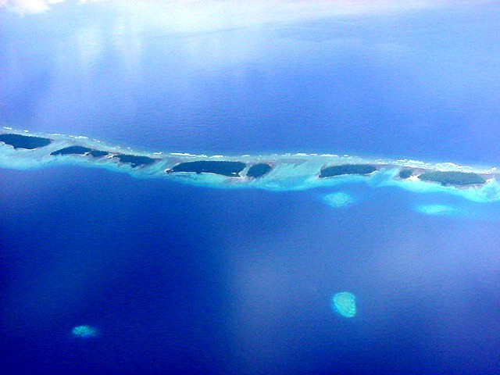

Table of contents
1. Compilation details | 17. General ecological features
2. Date | 18. Noteworthy flora
3. Country | 19. Noteworthy fauna
4. Name of site | 20. Social and cultural values
5. Map information | 21. Land tenure/ownership
6. Geographic coordinates | 22. Current land uses
7. General location | 23. Threats to the site
8. Elevation | 24. Conservation measures taken
9. Area Location | 25. Conservation measures proposed
10. Overview of the site | 26. Scientific and research activities
11. Ramsar criteria details | 27. Education activities
12. Justification of criteria | 28. Recreation and tourism
13. Biogeography | 29. Jurisdiction
14. Physical features | 30. Management authority
15. Hydrological values | 31. References
16. Wetlands types
Information Sheet on Ramsar Wetlands (RIS)

1. Name and address of the compiler(s) of this form: | John Bungitak, EPA - eparmi@ntamar.com  Assistance and advice provided by from Dr Bill Phillips (MainStream Environmental Consulting) – mainstream@mainstream.com.au – under funded kindly provided by WWF.
2. Date this sheet was completed/updated: | May 2003
3. Country: | Republic of the Marshall Islands
4. Name of Ramsar site: | Jaluit Atoll Conservation Area (JACA)
5. Map of the site included ?
5a) hardcopy | a) Yes √ (See below) No
5b) digital (electronic) format | b) to be advised
6. Geographical coordinates: | 6º00’ North, 169º 34’ East
7. General location: | Jaluit Atoll is the southern district centre of the Marshall Islands’ approximately 210 kilometres (130 miles) south east of Majuro, the capital of the Republic of the Marshall Islands (see map).
8. Elevation: | From sea level to 6 metres above sea level (the land areas).
9. Area: | Jaluit Atoll is a large coral atoll, covering 690 square kilometres (266 square miles) and includes a land area comprising 91 islets covering an area of 7 square kilometres (4.38 square miles). The Ramsar listed site is the Jaluit Atoll Conservation Area which is the entire atoll.
10. Overview: | Jaluit Atoll includes diverse marine and terrestrial habitats, including reefs, sandflats, lagoons, seagrass beds, deep water, mangroves and sand cays. It supports a wide range of species that are presently maintaining relatively healthy, reproducing populations. The entire atoll was designated a Conservation Area in 1999 as part of an effort to develop a program that would safeguard the marine and terrestrial ecosystems. Due to the limited land area of Jaluit Atoll, terrestrial species diversity is naturally limited although it does include turtle nesting beaches and seabird roosting islands in relatively stable condition. Maintaining healthy populations of terrestrial organisms and habitats are essential to the overall environmental health and long term sustainability of the atoll. In addition, these resources are important to the future promotion and success of the local ecotourism industry.

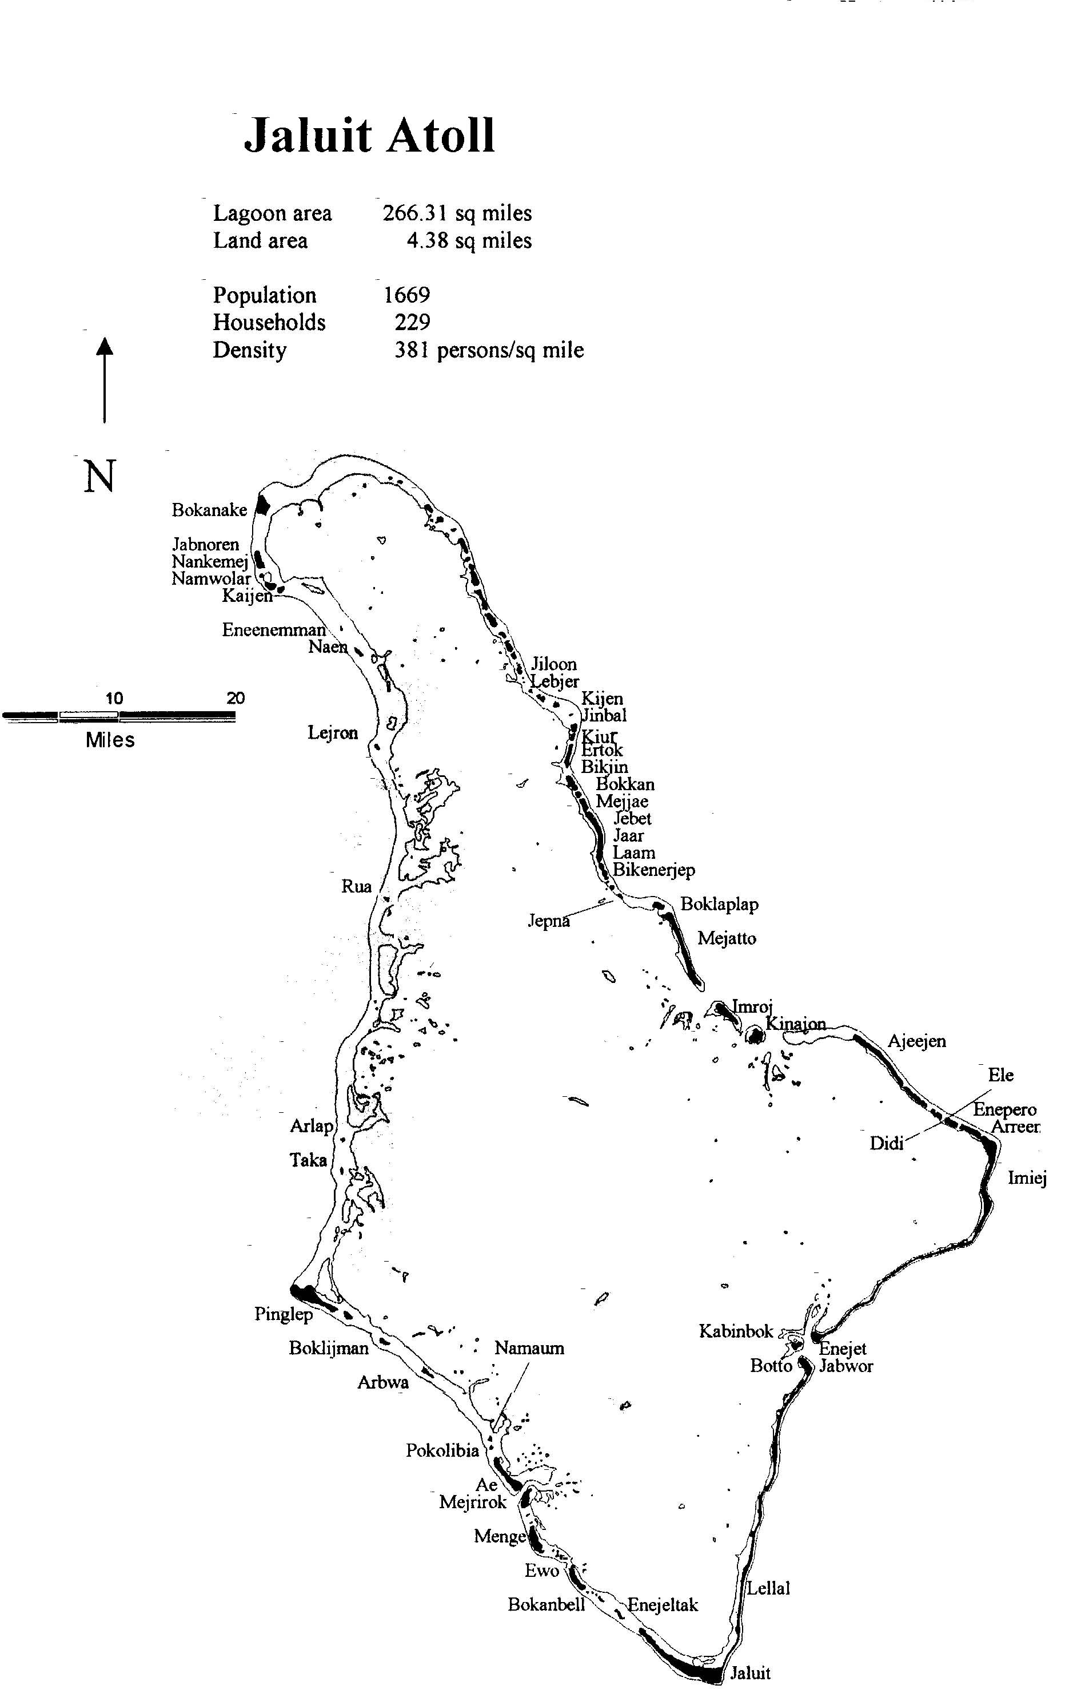
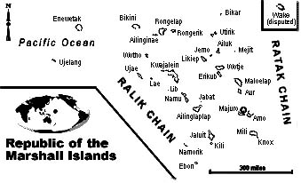
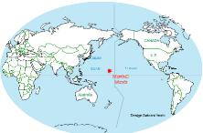

11. Ramsar site criteria met by the site:
The site qualifies as a Ramsar site against the following criteria (as provided in full below along with justification for their application in each case):
1 | 2 | 3 | 4 | 5 | 6 | 7 | 8

12. Justification of the criteria selected under 11 above:
Criteria for designating Wetlands of International Importance | Justification
Criterion 1: A wetland should be considered internationally important if it contains a representative, rare or unique example of a natural or near-natural wetland type found within the appropriate biogeographic region. | Jaluit is a large atoll with a wide range of relatively pristine and healthy ecosystems. The diverse marine and terrestrial habitats, including reefs, sandflats, lagoons, seagrass beds, deep water, mangroves and sand cays, support a wide range of organisms that are presently maintaining relatively healthy, reproducing populations. The system is representative of the types found in the region.
Criterion 2: A wetland should be considered internationally important if it supports vulnerable, endangered, or critically endangered species or threatened ecological communities. | Jaluit Atoll once provided breeding habitat for Hawksbill turtles (Eretmotchelys imbricata); an internationally endangered species. This has not been recorded recently, but it is hoped the species will return at some time in the future. Also notable here are the presence of Coconut and Mangroves crabs.
Criterion 3: A wetland should be considered internationally important if it supports populations of plant and/or animal species important for maintaining the biological diversity of a particular biogeographic region. | The high marine biodiversity within Jaluit Atoll is thought to be significant in contributing marine life to reefs not only within Jaluit Atoll, but also throughout the southern atolls of the Marshall Islands. Ocean-side reefs and atoll passes are pristine, with high percentage coral cover and biodiversity. Fishery resources, apart from commercially targeted invertebrate species (e.g. sea cucumbers [beche-de-mer], trochus, giant clams, black pearl shell and mangrove crabs), are healthy and support the island’s subsistence life style.
Criterion 4: A wetland should be considered internationally important if it supports plant and/or animal species at a critical stage in their life cycles, or provides refuge during adverse conditions. | See Criteria 3 above and 7 below. Jaluit is important for providing a breeding area for different marine species which contribute to the populations throughout the southern Marshall Islands.
Criterion 5: A wetland should be considered internationally important if it regularly supports 20,000 of more waterbirds. | Not applicable
Criterion 6: A wetland should be considered internationally important if it regularly supports 1% of the individuals in a population of one species or subspecies of waterbird. | Not applicable
Criterion 7: A wetland should be considered internationally important if it supports a significant proportion of indigenous fish subspecies, species or families, life-history stages, species interactions and/or populations that are representative of wetland benefits and/or values and thereby contributes to global biological diversity. | Jaluit has very healthy marine ecosystems with corresponding populations of reef fish and associated invertebrates. This includes Coconut crabs (Birgus latro) and mangrove crabs (Scylla serrata), trochus, (Trochus niloticus) a marine snail, sea cucumbers, a wide variety of reef fish, sharks, blacklip pearl oyster (Pinctada margaritifera) and four species giant clam (Tridacna gigas, T. maxima, T. squamosa and Hippopus hippopus )
Criterion 8: A wetland should be considered internationally important if it is an important source of food for fishes, spawning ground, nursery and/or migration path on which fish stocks, either within the wetland or elsewhere, depend. | See Criteria 7 above.

13. Biogeography:
13a) Biogeographic region: | Not known
13b) Biogeographic regionalisation scheme: | Not known
14. Physical features: | Jaluit Atoll has a ring of shallow coral reefs and islands surround the outer perimeter of the lagoon. The ecosystem has a wide range of habitat types ranging from deep water and lagoons, to seagrass beds, reefs, sandflats, mangroves and sand cays
15. Hydrological values: | All mangrove swamps in Jaluit Atoll rely on tidal flushing to keep the mangroves healthy. Water exchange flushes out the ecosystem – taking away harmful products and bringing in needed nutrients and animals. Several animal species found in mangrove ecosystems rely on this tidal flushing to complete their reproductive lifecycles.

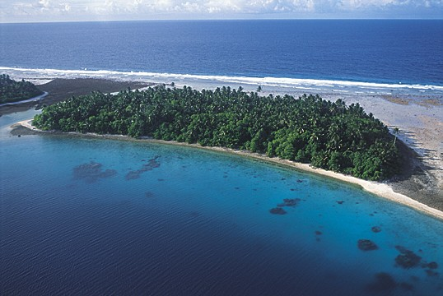
16. Wetland types:

a) presence:
As per the Ramsar Convention type listing shown below, those shown with a ☺are those found at Jaluit Atoll.

b) dominance:
The ranking of these types beginning with most dominant is as shown below:

Marine/Coastal Wetlands | Present | Ranking
A -- Permanent shallow marine waters in most cases less than six metres deep at low tide; includes sea bays and straits. | ☺ | 1
B -- Marine subtidal aquatic beds; includes kelp beds, sea-grass beds, tropical marine meadows. | ☺ | 4
C -- Coral reefs. | ☺ | 3
D -- Rocky marine shores; includes rocky offshore islands, sea cliffs.
E -- Sand, shingle or pebble shores; includes sand bars, spits and sandy islets; includes dune systems and humid dune slacks. | ☺ | 6
F -- Estuarine waters; permanent water of estuaries and estuarine systems of deltas.
G -- Intertidal mud, sand or salt flats. | ☺ | 7
H -- Intertidal marshes; includes salt marshes, salt meadows, saltings, raised salt marshes; includes tidal brackish and freshwater marshes.
I -- Intertidal forested wetlands; includes mangrove swamps, nipah swamps and tidal freshwater swamp forests. | ☺ | 5
J -- Coastal brackish/saline lagoons; brackish to saline lagoons with at least one relatively narrow connection to the sea. | ☺ | 2
K -- Coastal freshwater lagoons; includes freshwater delta lagoons.
Zk(a) – Karst and other subterranean hydrological systems, marine/coastal
Inland Wetlands
L -- Permanent inland deltas.
M -- Permanent rivers/streams/creeks; includes waterfalls.
N -- Seasonal/intermittent/irregular rivers/streams/creeks.
O -- Permanent freshwater lakes (over 8 ha); includes large oxbow lakes.
P -- Seasonal/intermittent freshwater lakes (over 8 ha); includes floodplain lakes.
Q -- Permanent saline/brackish/alkaline lakes. | ☺ | 9
R -- Seasonal/intermittent saline/brackish/alkaline lakes and flats.
Sp -- Permanent saline/brackish/alkaline marshes/pools. | ☺ | 8
Ss -- Seasonal/intermittent saline/brackish/alkaline marshes/pools.
Tp -- Permanent freshwater marshes/pools; ponds (below 8 ha), marshes and swamps on inorganic soils; with emergent vegetation water-logged for at least most of the growing season.
Ts -- Seasonal/intermittent freshwater marshes/pools on inorganic soils; includes sloughs, potholes, seasonally flooded meadows, sedge marshes.
U -- Non-forested peatlands; includes shrub or open bogs, swamps, fens.
Va -- Alpine wetlands; includes alpine meadows, temporary waters from snowmelt.
Vt -- Tundra wetlands; includes tundra pools, temporary waters from snowmelt.
W -- Shrub-dominated wetlands; shrub swamps, shrub-dominated freshwater marshes, shrub carr, alder thicket on inorganic soils.
Xf -- Freshwater, tree-dominated wetlands; includes freshwater swamp forests, seasonally flooded forests, wooded swamps on inorganic soils.
Xp -- Forested peatlands; peatswamp forests.
Y -- Freshwater springs; oases.
Zg -- Geothermal wetlands
Zk(b) – Karst and other subterranean hydrological systems, inland
Human-made wetlands
1 -- Aquaculture (e.g., fish/shrimp) ponds
2 -- Ponds; includes farm ponds, stock ponds, small tanks; (generally below 8 ha).
3 -- Irrigated land; includes irrigation channels and rice fields.
4 -- Seasonally flooded agricultural land (including intensively managed or grazed wet meadow or pasture).
5 -- Salt exploitation sites; salt pans, salines, etc.
6 -- Water storage areas; reservoirs/barrages/dams/impoundments (generally over 8 ha).
7 -- Excavations; gravel/brick/clay pits; borrow pits, mining pools.
8 -- Wastewater treatment areas; sewage farms, settling ponds, oxidation basins, etc.
9 -- Canals and drainage channels, ditches.
Zk(c) – Karst and other subterranean hydrological systems, human-made

17. General ecological features: | These are outlined above and immediately below.
18. Noteworthy flora | Jaluit Atoll has several mangrove forests. They are found on Jaluit Jaluit, Majrirok, Boknake, Imroj, Kinejon, Mejato, Pingelap, Ae and Taruk islands. They vary in size, diversity of flora and fauna, water exchange and usage. The largest mangrove forest is located on Jaluit Jaluit.
19. Noteworthy fauna | Two turtle species, the Green turtle (Chelonia mydas) and the Hawksbill turtle (Eretmochelys imbricata), have been reported from the lagoon and ocean reefs of Jaluit Atoll (SPREP, 2000). There is at least one island within Jaluit Atoll that has been reported as a turtle-nesting site.  There are several islands in Jaluit Atoll called “Bird Islands”. Several seabirds, including frigates, noddy terns, white-tailed tropicbirds, crested terns, brown boobies and white terns roost and nest on these islands. Nesting occurs in low vegetation and on the sand. Also found at Jaluit is the oceanic Micronesian pigeon (Ducula oceanica oceancia).  Coconut crabs (Birgus latro) are found in Jaluit Atoll. Anecdotal information indicates that these crabs occur on most of the islands within the lagoon.  The occurrence of the mangrove crab (Scylla serrata) in the mangrove forests of Jaluit Atoll is unique and rare.  The top shell, or trochus, (Trochus niloticus) is a marine snail that was introduced to the reefs on Jaluit Atoll in 1939 to establish a breeding population for commercial harvesting. They are commercially valuable for their mother of pearl shell, which is made into buttons and other ornamental objects.  Jaluit Atoll has a high diversity of sea cucumbers.  Reef fish are the most widely utilised and valuable marine resource within Jaluit Atoll. They are harvested for subsistence, off-island demand, special occasions and commercial activities. A wide ranges of species are targeted.  Sharks are regarded throughout the world as major attractions for ecotourism (e.g. scuba diving and snorkelling).  The tropical blacklip pearl oyster Pinctada margaritifera is the only commercially valuable species of tropical pearl oysters in Jaluit Atoll. The artificial culture of this species has been developed in other Pacific nations that have produced gem quality back pearls. This industry is in its infancy within the Marshall Islands.  Four species of giant clam are present in Jaluit Atoll: Tridacna gigas, T. maxima, T. squamosa and Hippopus hippopus (SPREP, 2000).
20. Social & cultural values | The current population, at any one time on Jaluit Atoll is approximately 1000 individuals.  Each inhabited island has a traditional hierarchical system centering around the traditional chief, (Iroij). Each Iroij selects one or more “Alap” who manage the lands. Dir- jerbal are the people who work and live on the land.  Although the Iroij may not hold absolute power as they once did, they are still highly respected by communities and play a vital role in the atoll’s politics. All major decisions regarding the communities are taken to the Iroij for their approval (Marshall Island Government, 2000).  Traditionally, Iroij own all land and water resources within a community’s jurisdiction. By birthright, Iroij have absolute power – including all resource use, preservation and management.  Landownership in Jaluit Atoll is different from that of other Marshallese atolls. On most atolls ownership extends over the land and coastal areas, not deep water and submerged reefs. On Jaluit Atoll, however, ownership includes land, coastal, deep water and submerged reefs. In the past, Jaluit Atoll communities battled one another for ownership of these reefs within the lagoon. Some communities own reefs on the opposite side of the atoll from where the community actually lives. These rights are maintained to this day.  This jurisdiction issue is an extremely important consideration when determining the most appropriate resource management system for the atoll. Landownership has been carefully incorporated in the Jaluit Atoll Environmental Resource Plan of Management (JAPOM).  This traditional system, however, has weakened with time. More and more of the resource management responsibility, especially with regards to marine resources, have fallen under the responsibilities of the Local Government Council.  Unfortunately, this change of responsibility has led to a slow decline in traditional awareness of resource values. This, in turn, has resulted in a decline in sustainable management practices. Lack of adequate enforcement has resulted in overexploitation of resources, mostly for Off-island Demand.  Traditional resource management is based on a system whereby the Iroij would ‘set aside’ one or more parcels of land and/or reef as ‘Mo’ (taboo areas). The Iroij would declare what animals are protected, and for how long. Some communities have only one Mo, while others have several.  Usually the removal of any animal or plants within the Mo was forbidden. Special permission was needed from the Iroij to enter the area to collect anything. Some Mo were seasonal while others were more or less permanent. Resource harvesting is limited to special traditional occasions (e.g. wedding or funeral feasts).  In effect, Mo function as ‘No Take’ zones. Enforcement of Mo’s remains the responsibility of the communities themselves.
21. Land tenure/ownership
21a) site: | The entire atoll was designated a Conservation Area in 1999 as part of the South Pacific Biodiversity Conservation Program (SPBCP) which was managed through the South Pacific Regional Environmental Programme (SPREP) as part of an effort to develop a program for the atoll that would safeguard the marine and terrestrial ecosystems.  Each of the inhabited islands has a Local Government that consists of a Mayor and a Council that holds jurisdiction over their own atoll including the land, lagoons and all waters up to 5 nautical miles offshore from their reefs. Each Local Government is based on the national government legislative system, however they have the power to introduce laws and regulations pertinent to their atoll’s affairs (Marshall Island Government, 2000). Local councils have jurisdiction over the majority of coastal and marine management issues.
21b) surrounding area: | The Government of the Republic of the Marshall Islands (RMI) is a democracy, consisting of a 33 member parliament (Nitijela) whom represent the 24 inhabited atolls and islands of the nation. The President, who is elected by parliament members, heads the government.  Each of the inhabited islands has a Local Government that consists of a Mayor and a Council that holds jurisdiction over their own atoll including the land, lagoons and all waters up to 5 nautical miles offshore from their reefs. Each Local Government is based on the national government legislative system, however they have the power to introduce laws and regulations pertinent to their atoll’s affairs (Marshall Island Government, 2000). Local councils have jurisdiction over the majority of coastal and marine management issues (SPREP, 1999).  In addition to the western style Democratic governments, the traditional Marshallese system is also strong and deeply respected. The traditional system is a hierarchical system with paramount chiefs (or Iroij) playing important roles in politics. A council of 12 Iroij act as an advisor group to the parliament, especially on matters that affect customary law, traditional practice and land tenure (Marshall Island Government, 2000).
22. Current land use
22a) within the Ramsar site: | Mostly subsistence use by the population of less than 2000 people. Some eco-tourism – see 28 below.
22b) surrounding area or catchment: | Commercial fishing fleets visit the surrounding seas.
23. Factors (past, present or potential) adversely affecting the site’s ecological character
23(a) at the site: | Stock populations of some specifically targeted animals have been and are still being over-exploited, due to commercial and off-island demand pressures. These resources, particularly giant clams, sea cucumbers (bech-de-mer), pearl oysters and trochus, are in great danger of becoming locally extinct. Unfortunately, the majority of the commercial resource collection activities have been carried out without following sustainable resource harvesting practices. Over-exploitation of resource stocks has occurred. Urgent management actions options need to be initiated to prevent further decline of these stocks.  In addition, the recent addition of the Jaluit Atoll Fish Base has commercialised atoll fishing. All fish are sold for off-island consumption in Majuro and Ebeye. The majority of the commercial resource collection activities have been carried out without following sustainable resource harvesting practices and over-exploitation of resource stocks has occurred.  Some of the terrestrial resources have been severely impacted. Mangrove crabs and coconut crab populations have already been over-harvested and anecdotal information indicates that mangrove crabs may be locally extinct.  Land clearing for the extension and up-grading of the road between Jabwor and Jaluit Jaluit has caused localised physical removal of all vegetation and associated wildlife. Sand dredging associated with this development has also degraded these shallow areas and greatly increased sedimentation load in the nearby marine environment. Invasive species are also a concern.
23(b) around the site: | Rising sea levels associated with global warming will impact these low lying islands and atolls.  Cyclones, while a natural part of the ecology of the area do have a devastating impact on the entire atoll and all of its habitats.
24. Conservation measures taken: | The Jaluit Atoll Conservation Area (JACA) was declared in 1999. The Conservation Area includes the entire atoll area. It was developed by the combined efforts of the Jaluit Atoll Development Association (JADA), the Conservation Area Coordinating Committee (CACC), the Jaluit Atoll Local Government (JALG), the communities, the traditional leaders and the RMI Environment Protection Authority (EPA).
25. Conservation measures proposed but not yet implemented: | The JAPOM has been prepared and is being implemented. The goals and objectives of this plan are to provide all stakeholders with an environmental resource management framework, which will serve to maintain healthy marine and terrestrial environments for future generations. The options set forth in the JAPOM are specifically designed to promote and empower all communities to actively participate in the protection of the atoll’s valuable resources, while allowing for sustainable use.
26. Current scientific research and facilities: | There are several comprehensive reports written about Jaluit Atoll. Combined, they form the foundation on which the present Jaluit Atoll Conservation Area project is based.  Previous studies include:  - SPREP (2001) Feasibility Assessment & Support for Community Ecotourism Development prepared by Robin Aiello. This report reviews the potential for ecotourism on Jaluit Atoll, and develops a recommended guesthouse accommodation project with several guided tour options.  - SPREP (2000) Marine Resource Survey of Jaluit Atoll, RMI for Marine Management & Conservation Area Project, prepared by Stephen Lindsay. This report is a detailed survey of the status of marine resources within Jaluit Atoll, and recommends a marine monitoring program to collect data to help develop appropriate management plans for resource use.  - Jaluit Atoll Development Association (2000) Jaluit Atoll Conservation Area Business Plan.  - SPREP (1999) Project Preparatory Document, Jaluit Atoll Conservation Area Project RMI, This report outlines the rationale behind selecting Jaluit Atoll as a Conservation Area.  - Thomas, Emily (1998) Community-based Tourism Development for Jaluit Atoll, University of Oregon, Micronesia and South Pacific Program. This document reports on the completion of three activities recommended in a previous report Miller (1997): 1) beach clean-up activity, 2) a tour guide training session for men & women, and 3) suggested text for a Jaluit Atoll Guidebook.  - Miller (1997) A Community-based Tourism Plan for Jaluit Atoll, University of Oregon Micronesia and South Pacific Program. This report reviews natural, cultural & historical resources, infrastructure, and the level of community support on Jaluit Atoll. It lays out the suggested framework for community-based tourism development in Jaluit.  - Deunert, B. et al (1996) Anthropological Survey of Jaluit Atoll: terrestrial and underwater reconnaissance surveys and oral history recording, Republic of Marshall Islands Historical Preservation Office. This report documents significant historical features and relics, both on land and underwater. They are documented, mapped and analysed for universal significance.
27. Current conservation education: | A community awareness program is included in the plan of management (JAPOM).
28. Current recreation and tourism: | Low level at present. There are several small ecotourism projects and activities including five traditional-style ecotourist guesthouses - built on the northern end of Jaluit Jaluit that were opened to the public in mid-2002. A series of associated guided tours were also developed, but have not been used. Mangrove forest pathways have been built by local community members and the CASO through the Jaluit Jaluit mangrove forest.  In 2002 Air Marshall Islands changed their flight schedule to link Jaluit and Kwajelein Atolls. This has the potential to bring tourists from the military base. The flights have been scheduled to encourage people to spend a long weekend on Jaluit Atoll.
29. Jurisdiction: | The Government of the Republic of the Marshall Islands (RMI), located approximately 210 kilometres (130 miles) north west in Majuro, the capital of the Republic of the Marshall Islands.
30. Management authority: | The Environmental Protection Agency has the overall responsibility for the Conservation Area. Day-to-day management decisions are made jointly with the Conservation Area Coordinating Committee (CACC), which is composed of traditional landowners, community members, and EPA representatives. The Conservation Area Supporting Officer (CASO) is responsible for carrying out day-to-day activities within the Conservation Area, such as public awareness and community liaison.
31. Bibliographical references: | Marshall Island Government, 2000. The Marshall Islands – Living Atolls Amidst the Living Sea. The National Biodiversity Report of the Republic of the Marshall Islands. RMI Government Publication. 345pp. ISBN: 982-9045-02-1.  Salm, R. V., Clark, J. and Siirila, E. 2000. Marine and Coastal Protected Areas: A guide for planners and managers. IUCN publication 371pp. ISBN: 2-8317-0540-1.  SPREP, 1993. Republic of the Marshall Islands, National Environment Strategy (NEMS). Part A. State of the Environment Report. SPREP Publication 90pp. ISBN: 982-04-0045.  SPREP, 1999. Coastal Management Profiles: A Directory of Pacific Island Government and Non-Government Agencies with Coastal management Related responsibilities. SPREP publication. 209pp ISBN: 982-04-0198-4.  SPREP, 2000. Marine resource Survey of Jaluit Atoll, Republic of the Marshall Islands. Jaluit Atoll Conservation Area. SPREP publication. 63pp.  SPREP, 2001. Feasibility Assessment and Support for Community Ecotourism Development. Jaluit Atoll Conservation Area. 124pp  Tibon, J. and Mohamed, N. 1999. The Republic of the Marshall Islands Biodiversity Strategy and Action Plan. National Government Publication. 25pp  Ward, T. S., Heinemann, D. and Evans. N. 2001. The role of marine reserves as fisheries management tools: a review of concepts, evidence and international experience. Bureau of Rural Science, Canberra, Australia. 192pp.

