2018
Water Quality Assessment of Fogafale Lagoon, Tuvalu
SPC | GEM Division
IW Ridge to REef project report
Emma Newland

Introduction

Purpose
As part of the Coastal Health Monitoring component of the Tuvalu IW R2R Project, baseline water quality surveys and analysis were carried from 14th to 17th September 2018. The coastal health monitoring program is designed to characterise ecological health of, and assess causal links between land based activities, and algal blooms and ciguatera occurrences in the Fogafale lagoon adjacent to populated areas of Funafuti atoll in Tuvalu. Baseline assessments of the Tafua pond, adjacent to the IW R2R demonstration dry-litter piggery site, was also conducted. We report on six measures of water quality: turbidity, dissolved oxygen, the dissolved nutrients nitrate- and nitrite-nitrogen, ammonical nitrogen, phosphate-phosphorous, and coliform counts. A selection of field samples were provided to the USP-IAS laboratory as a quality control measure of the analysis of nutrients by the field equipment YSI 9300 Photometer.

Recent surveys in the same context include a biodiversity assessment, algal and water quality assessments conducted under the national STAR R2R project, and an ongoing ciguatera monitoring program conducted by the Department of Fisheries. This field sampling event was therefore designed to complement existing work. In discussion with the STAR R2R Project and the technical team from USP that has assisted on lagoon assessments, it was decided to conduct water quality monitoring at the same monitoring sites as the STAR R2R to provide additional temporal data, and to asses any correlations between data sets. STAR R2R staff and stakeholders formed the bulk of the survey team, promoting the existing national expertise, and encouraging citizen science and continuity of knowledge acquisition.

Ongoing monitoring of the Fogafale lagoon is critical in building up the body of knowledge to assess the changing condition of the lagoon and ecosystem processes, and to validate any intervention activities on land to improve water quality. To this end a goal of the event was to evaluate necessity and opportunities to develop a comprehensive “Coastal Health Monitoring Program” that could be embedded in existing working arrangements.

The SPC – R2R mission team consisted of the Regional IW R2R Science Officer, Emma Newland, assisted by the Tuvalu IW Project Manager, Pesega Lifuka. The mission team arrived on Thursday 13th of September and field activities were carried out on 14th and 17th of September, with lab analysis of nutrients and coliform on 14th and 15th September.

Sites
Tuvalu is an atoll country consisting of nine atolls, with a total land area of 26 km² dispersed over 1.2 million km² of the Pacific Ocean. Funafuti is the capital, a coral atoll with a continuous eroded platform surrounding Fogafale Lagoon.

Water quality samples and field measurements were taken at 13 sites across Funafuti Tuvalu. Three of the sites are within Tafua Pond on Funafuti the remaining 10 sites are within Fogafale lagoon, including a reference site at the Conservation Area. The sites chosen are those used in the National STAR R2R water and algal monitoring (Table 2). An additional site at the northern end of the dumpsite was added to capture any impact from immediate discharge from that source.

Two sampling campaigns were conducted to factor in changes in analyte concentrations that can occur due to temporal and tidal differences. The first sampling occurred during a mid-morning high tide, the second sampling occurred during early morning low tide. The pond was sampled only once in the afternoon of a high tide.

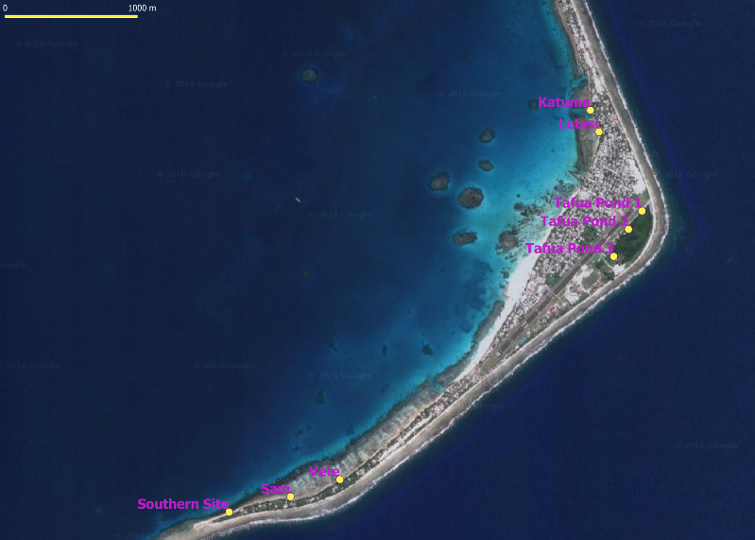
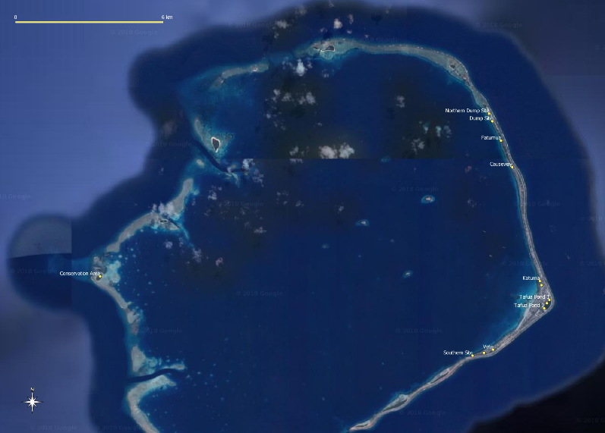
Figure 1: Locations of water quality monitoring sites at Funafuti, Tuvalu

Methodology

Sample Collection
Water samples were collected following protocol outlined in the EPA South Australian monitoring, evaluation and reporting program for aquatic ecosystems: Rationale and methods for the assessment of nearshore marine waters (Gaylard, Noble, & Nelson, 2013). Water samples were collected by a survey team consisting of the IW R2R RPCU Science Officer, IW R2R Project Manager, STAR R2R staff and three high school students from xxx High School.

Before sampling, the collection containers were rinsed three times with ambient water. Samples were collected on two non-consecutive days to allow for tidal and time variations.

All samples were analysed at the Department of Fisheries laboratory, using the YSI 9300 Photometer and EC Compact plates. Samples were delivered to the lab within one hour of collection and were analysed immediately.

A multi-parameter sonde (YSI ProDSS) was used to log water quality parameters including temperature, electrical conductivity, pH and dissolved oxygen at each location (n = 3 per transect).

A subset of samples were analysed at the University of the South Pacific – Institute of Applied Sciences laboratory to provide quality control of the field equipment. Samples were kept refrigerated and delivered to the lab within 48 hours of sampling. The laboratory analytical methods for all of the sampled parameters are provided in Table 3.

Data Analysis
Once the data were compiled from both sampling campaigns, they were sorted based on criteria including the time of day sampled and water source (lagoon water and pond water). Average and standard deviations were calculated for each analyte concentration within each water source and time. A t-test was used to determine if there was a significant difference between samples collected at high and low tide; as well as a comparison of field equipment versus the laboratory analytical methods to determine any significant difference in values.

Survey Results

This section presents a broad overview of the results gathered during the baseline sampling campaigns, and discusses important water quality characteristics found within the Fogafale lagoon and Tafua Pond. The average concentrations found in lagoon and pond water samples for each analyte can be found in Table 1. ​​​Two sources of default guideline values (DGVs) have been used to assess water condition. The first is taken from the Australian and New Zealand Guidelines for Fresh and Marine Water Quality (ANZECC & ARMCANZ, 2000) for slightly disturbed, Australian tropical inshore marine systems. The second have been more recently derived through the Integrated Marine and Coastal Regionalisation of Australia guidelines and are specific for the Central Reef bioregion of Australia (ANZECC & ARMCANZ, 2018). DGV’s can provide a generic starting point for assessing water quality. No water quality guidelines have been set for Tuvalu and the use of the ANZECC default trigger values should only be used until site- or ecosystem-specific values can be generated.

Table 1: Average and range concentration of nutrients, average values for each water source (Lagoon and Pond). Default guideline values from ANZECC and IMCRA.
Analyte | Average (mg/L) | Range  (mg/L) | Lagoon HT (n=9) | Lagoon LT (n=10) | Pond (n=4) | Default guideline values
P-PO4 | 0.053 | 0.02 – 0.15 | 0.05 | 0.05 | 0.4
 | 0.68 umol/L | 0.21 – 3.16 umol/L | 0.58 umol/L | 0.54 umol/L | 4.24 umol/L | 0.122umol/Lª
N-NO3 | 0.050 | 0.009 – 0.425 | 0.19 | 0.25 | 0.16 | 2 – 8ug/L^{b}
 | 3.51 umol/L | 0.16 – 6.92 umol/L | 3.10 umol/L | 3.95 umol/L | 2.58 umol/L | 0.17umol/Lª
N-NO2 | 0.006 | 0.003 – 0.018 | 0.02 | 0.02 | 0.02
NH3 | 0.025 | 0.008 – 0.058 | 0.03 | 0.02 | 0.01
NH4^{c} | 0.026 | 0.011 – 0.076 | 0.02 | 0.02 | 0.01 | 1 – 10ug/L^{b}
TN^{d} | 0.075 | 0.023 – 0.443 | 0.071 | 0.022 | 0.05 | 100ug/L^{b}
e.coli count | 6 | 0 - 31 | 4 | 6 | 15
coliform count | 7 | 0 - 42 | 4 | 5 | 16
T
pH |  |  |  |  |  | 8.0 - 8.4^{b}
DO |  |  |  |  |  | 90% sat^{b}
ª = Default guideline values for IMCRA Central Reef bioregion, summer time values (ANZECC 2018)
^{b} = Default guideline values from NWQMS for tropical Australia for slightly disturbed ecosystems, inshore marine systems (ANZECC 2000)
^{c} = NH4 calculated from NH3 values
^{d} = TN calculation assumes little to no significant contribution from TON, can only be interpreted as an estimate

Nutrients
In this study, nitrogen was tested in the form of nitrate, nitrite and ammonia; and phosphorous in the form of phosphate (Figure 2). These species were included because they influence aquatic primary production - growth of benthic microalgae (periphyton), photosynthetic bacteria, phytoplankton, macroalgae, and aquatic vascular plants. Increases in the availability of these nutrients are associated with an increase in primary production. The invasive seaweed species Sargassum polycystum is of particular concern in Fogafale lagoon and recent studies suggest that a second species of brown algae, Padina cf. boryana, was becoming more abundant and displacing Sargassum in several areas (Iese, de Ramon N'Yuert, & Vanoh, 2018). Excess nutrient load sources have been identified as human waste (mostly originating from unlined septic tanks, pit toilets and occasional open defecation in the lagoon), animal waste from piggeries, and inputs of phosphates from detergents and chemical fertilisers. Very high concentrations of nitrate and phosphate were measured at Letasi and Tafua Pond respectively, these two sites have been omitted from charts depicting all site averages and are presented in Figure 3.
Figure 2: Average and standard deviation of measured nutrient concentrations.

Figure 3: Average and standard deviation of measured nutrient concentrations at Letasi and Tafua Pond sites

The average measurement within the lagoon for nitrate-nitrogen (NO3-N) was 0.050 ± 0.10mg N/L with a range of 0.009 – 0.425 mg N/L. The average nitrate measurement within Tafua pond was 0.04 ± 0.02mg N/L with a range of 0.01 to 0.06mg N/L(Table 1). All sites measured higher than the ANZECC & ARMCANZ (2000) DGV’s and the IMCRA (2018) DGV’s for nitrate (Figure 5 and Figure 6). High values from Letasi and Tafua pond have been omitted as outliers and are presented in .

The average measurement within the lagoon for nitrite-nitrogen (NO2-N) was 0.006 ± 0.004mg N/L with a range of 0.003 – 0.018mg N/L .The average nitrite measurement within Tafua pond was 0.005 ± 0.001mg N/L with a range of 0.003 – 0.006mg N/L (Table 1).

The average measurement within the lagoon for ammonical nitrogen (NH4-N) was calculated as 0.026 ± 0.019mg N/L with a range of 0.011 – 0.076 mg N/L. The average N-NH4 measurement within Tafua pond was calculated as 0.01 ± 0.00 mg N/L (Table 1). All sites measured higher than the ANZECC & ARMCANZ, (2000) DGV’s (Figure 6).

Estimate values for total nitrogen (TN) were calculated for all sites, assuming little to no significant contribution from total organic nitrogen. The average measurement within the lagoon for TN was 0.075 ± 0.1 mg N/L with a range of 0.023 – 0.443 mg N/L. The average TN measurement within the pond was 0.05 ± 0.02 mg N/L, with a range of 0.04 -0.08 mg N/L (Table 1). Letasi is the only site that exceeds the ANZECC & ARMCANZ (2000) DGV for TN (Figure 7).

The average measurement within the lagoon for phosphate (PO4-P) was 0.55 ± 0.27µmol P/L with a range of 0.21 – 3.16µmol P/L. The average PO4-P measurement within the pond was 3.05 ± 0.10µmol P/L with a range of 2.95 – 7.79 µmol P/L. All sites measured higher than the IMCRA (2018) DGV’s for phosphate (Figure 8).

Concentrations of nutrients did not significantly differ (p-value > 0.05) when samples were separated by analyte and tide nor did they differ significantly (p-value > 0.05) from values derived from laboratory methods (Table 4).

Figure 4: Nitrate concentration compared with DGV's for slightly disturbed tropical inshore marine waters (ANZECC 2000)

Figure 5: Nitrate concentration compared with DGV's for Australian Central Reef bioregion, summer values (IMCRA 2018)

Figure 6: Ammonium concentration compared with the DGV's for slightly disturbed tropical inshore marine waters (ANZECC, 2000)

Figure 7: Total nitrogen concentration compared with DGV's for slightly disturbed tropical inshore marine waters (ANZECC, 2000)

Figure 8: Phosphate concentration compared with DGV's for Australian Central Reef bioregion, summer values (IMCRA 2018)

Previous studies by PACE-SD team from USP, led by Dr N’Yuert have used chlorophyll as a proxy for land based nitrates. These results have been used to identify preliminary relationship between nitrates and chlorophyll. The results show a relationship between the two parameters, particularly at the high concentrations of both parameters at the Letasi site. Data was collected at different times and tides, amd influences of these are not explored. Further investigations will need to be carried out simultaneously to correlate this relationship.

Figure 9: Chlorophyll (data collected by Dr N'Yuert) and nitrate concentrations at sampling sites

Pathogens

Discussion

The water quality conditions measured during this sampling campaign exceeded Australian derived default value guidelines for N-Nitrate, P-Phosphate and N-Ammonium. Values for TN were within range for all sites except Letasi. Not all analytes measured are represented by a guideline value.

Previous studies have shown that the potential source of water pollution in the lagoon is from bottomless septic systems used by a majority of households (Fujita, et al., 2013; Iese, de Ramon N'Yuert, & Vanoh, 2018) and through groundwater dynamics, leaks from these systems are reaching the lagoon on the ebb tide (Fujita, Inoue, Sato, Kuwhara, & Yokoki, 2012).

Letasi is approximately in the middle of the densely populated main settlement and multiple lines of evidence suggest that nutrient loads from unsealed septic systems travel through groundwater dynamics, and is entering the lagoon around this site. Previous studies have observed high levels of microbial biomass and changes in Eh that suggest nutrient loads from coastal communities flows into the coastal system near the Letasi site (Fujita, et al., 2013). Other studies have observed highest sargassum biomass and chlorophyll concentrations (Iese, de Ramon N'Yuert, & Vanoh, 2018) at the Letasi site. This study has observed high levels of nitrate and the faecal indicator bacteria E.coli at the Letasi site. These results indicate that the source is from leaks in unsealed septic systems as the wastewater includes human waste.

It is important to note that sample size for this report is relatively small and represents samples taken during a short time frame. It may not capture the full seasonal range of possible concentrations, and is not necessarily representative of the entire Fogafale lagoon. The findings suggest no significant temporal difference between analyte concentrations, (p<0.05) nor between concentrations derived from field equipment and laboratory methods (p<0.05). With more data from future sampling events there may be a great difference between analyte concentrations at high and low tides.

Recommendations
The purpose of this report is to provide the Fogafale lagoon with a snapshot picture of water quality, to which future conditions can be compared, and to identify relationships with previously reported data. The report provides the baseline data for the dry-litter piggery installation at the Tafua Pond, this is the IW R2R Project environmental stress reduction activity that contributes to reduction in municipal waste pollution entering the water system.

It is also an example of a starting point for developing a robust lagoon health monitoring program. Such a program should collect samples on a regular basis to increase understanding of variations in water quality that occur naturally in the area, and include biological sampling.

It is recommended that the agency mandated for water quality monitoring for ecological and public health measures develop such a robust monitoring program that will provide the appropriate temporal and spatial data to build a more accurate picture of lagoon health. The IW R2R Project will continue to conduct monitoring twice a year for project monitoring purposes, however it must be stressed that this will not adequately capture variations and their potential causes and impacts.

Appendix 1: Sampling Strategy
Sample collection at each site was undertaken by sampling three replicate 1.5 litre water grab samples in three locations of each 25m interval location mixed into a 25-litre container. After 3x3 replicates the water in the container was mixed thoroughly and sub-sampled. This process is repeated across the transect for 10 of the 13 transects (n = 10) to provide a snapshot of water nutrient concentration (nitrate, nitrite, ammonia, and phosphate). Compositing water samples is a method that is commonly used to reduce analytical costs of environmental sampling and with careful planning may reveal the same information as analysing many samples while still retaining, if not increasing, the precision of sample-based interferences (Gaylard, Noble, & Nelson, 2013).

During the second survey, the collection method was modified. Three replicate 1.5 litre water grab samples at each 25m interval location mixed into a 25-litre container. After three replicates the water in the container was mixed thoroughly and sub-sampled. This process is repeated across the transect for 8 of the 13 transects (n = 8) to provide a snapshot of water nutrient concentration (nitrate, nitrite, ammonia, and phosphate).

Transect length = 50m
Figure 10: Schematic of composite sampling process at each site.

Appendix 2: Tables

Table 2: Sampling sites and GPS coordinates
SITE | Latitude | Longitude
Northern Dump Site | -8.45143 | 179.1799
Dump Site | -8.45421 | 179.1811
Fatumua | -8.46127 | 179.1842
Causeway | -8.47089 | 179.1884
Katuma | -8.51244 | 179.1984
Letasi | -8.5139 | 179.199
Vete | -8.5374 | 179.1814
Sam | -8.53856 | 179.178
Southern Site | -8.5396 | 179.1739
Conservation Area | -8.51072 | 179.0377
Tafua Pond 1 | -8.51925 | 179.202
Tafua Pond 2 | -8.52049 | 179.201
Tafua Pond 3 | -8.52232 | 179.2

Table 3: Laboratory analytical methodology for quality check
Analyte | Method Reference
Nitrate | AP-4500-NO3 I
Nitrite | AP-4500-NO3 I
Ammonia | AP-4500-NH3 H
Phosphate | AP-4500-P G

Table 4: Output p-values for significant differences in analyte concentration when separated by tide; and between field and laboratory methodology
 | HT:LT | field:lab method
Nitrate | 0.65 | 0.89
Nitrite | 0.95 | 0.53
Ammonia | 0.24 | 0.10
Phosphate | 0.60 | 0.57

References

ANZECC & ARMCANZ. (2000). Australian and New Zealand Guidelines for Fresh and Marine Water Quality: Volume 1, The Guidelines. Canberra: Australian and New Zealand Environment and Conservation Council.
ANZECC & ARMCANZ. (2018). Australian IMCRA Mesoscale Bioregions — Derivation methodology for physical and chemical stressor default guideline . Canberra: Australian and New Zealand Environment and Conservation Council (ANZECC) & Agriculture and Resource Management Council of Australia and New Zealand (ARMCANZ).
Fujita, M., Inoue, R., Sato, S., Kuwhara, Y., & Yokoki, H. (2012). Run-off mechanism of domestic wastewater into lagoon side coast on Funafuti Atoll Tuvalu. Journal of Japan Society of Civil Engineers, 68.
Fujita, M., Suzuki, J., Sato, D., Kuwahara, Y., Yokoki, H., & Kayanne, H. (2013). Anthropogenic impacts on water quality of hte lagoonal coast of Fongafale Islet Funafuti Atoll Tuvalu. Sustainable Science, 381-390.
Gaylard, S., Noble, W., & Nelson, M. (2013). The South Australian monitoring, evaluation and reporting program for aquatic ecosystems: Rationale and methods for the assessment of nearshore marine waters. EPA, Western Australia.
Iese, V., de Ramon N'Yuert, A., & Vanoh, R. (2018). Ridge to REef Mission Report: Data Analysis and Vetiver Planting Training.
UNESCO-IHE Institute for Water Education,. (2016). Water quality in the tropics and subtropics: specifics, challenges and research needs.

